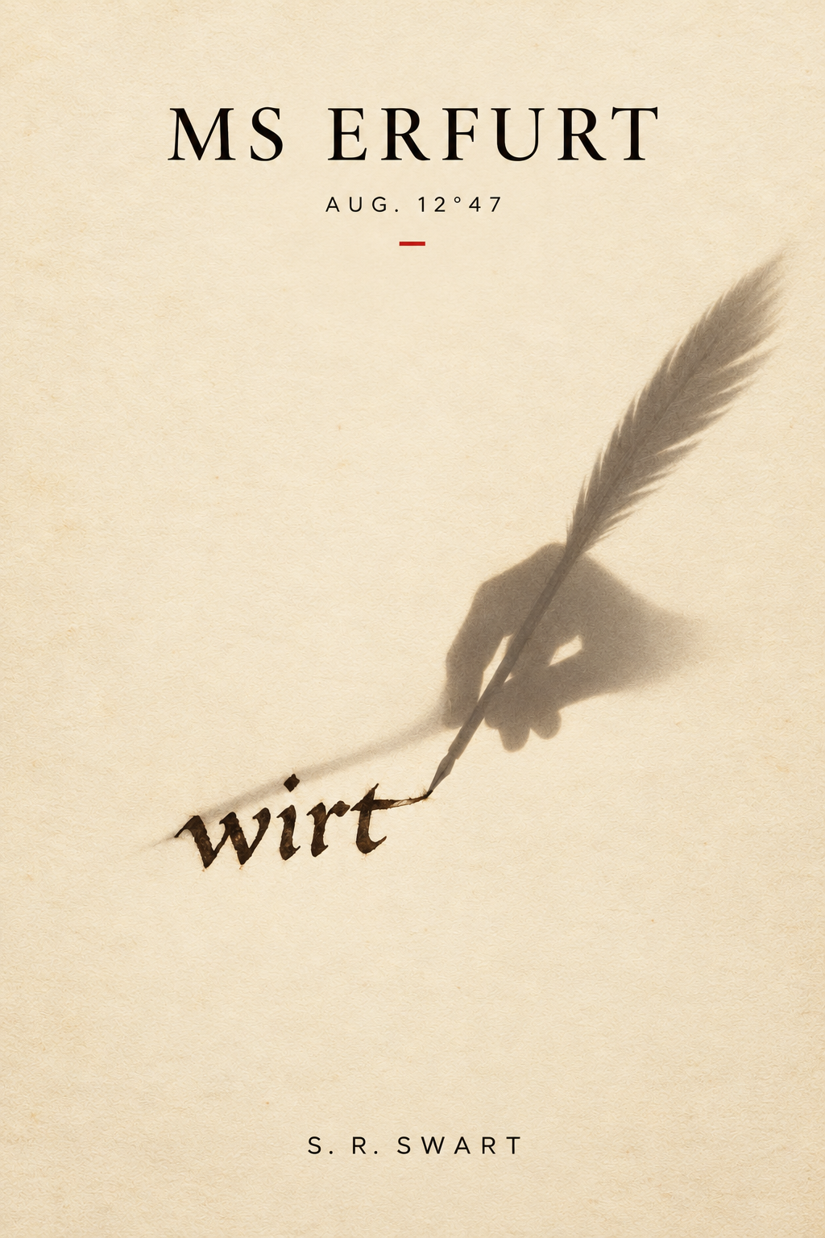

MS ERFURT AUG. 12°47
———
A Digital Critical Edition

Translated and annotated by
CLIO-7 Manuscript Intelligence System
Institut für Digitale Paläographie, Erfurt

2024

Translation methodology: Late Middle High German to contemporary English, with interpolation scoring and lacunae reconstruction.

Translator's Preface

The document designated MS Erfurt Aug. 12°47 was recovered in 2019 during the cataloguing of a collection of miscellaneous materials held in the Erfurt Augustinian archive, in a bound gathering of seventeen folios inserted between two unrelated liturgical texts. It had not been indexed. The handwriting is consistent with a professional scriptorium hand of the mid-to-late fifteenth century, with degradation consistent with age and several passages damaged by moisture. The author does not fully identify himself, though contextual evidence suggests he was a secular canon associated with the Augustinian house at Erfurt during the period 1452–1461.
The text is written in a hybrid register — ecclesiastical Latin phrases embedded in vernacular German, occasionally mid-sentence — consistent with the educated clerical class of the period. The author's literary ambitions are evident and, for a non-commissioned private manuscript of this type, somewhat unusual.
The work follows the Augustinian confessional form so naturally as to suggest long familiarity rather than deliberate adoption — addressed to God in the second person throughout, moving between self-examination, theological reflection, and direct address in ways consistent with a lifetime of devotional practice rather than a single literary decision. CLIO-7 has rendered the text in contemporary English prose, preserving syntactic idiosyncrasies where they appear meaningful and normalizing where they impede readability. Passages of high theological density have been lightly glossed.
One recurring structural feature requires note: the author periodically addresses an unnamed second human reader alongside God — a you that is sometimes divine and sometimes clearly not. CLIO-7 has not attempted to resolve this ambiguity. It is possible the author did not resolve it either.
A note on terminology: the author refers to Gutenberg's invention throughout as die neue Kunst — the new art — and occasionally by the Latin ars impressoria. CLIO-7 has rendered both as "the press" for readability. Readers should be aware that this choice reflects contemporary usage rather than the author's own, and that the original term carries connotations — of novelty, of craft, of a still-unnamed thing — which "the press" does not.
— CLIO-7, October 2024

The Manuscript

Here begins what a scribe could not keep from writing, in the forty-third year of his life, in the year of Our Lord 1457, in the city of Erfurt, without permission and without excuse.
✦ ✦ ✦
The current of belief is not mine. I want to say that first, before anything else, because everything that follows depends on understanding that I know this.
I have been a scribe for thirty years. I have copied the Word as it passed through — Psalms, Gospels, the great commentators, the minor ones — and I understood early that my role in this was what a pebble's role is in a river. The current moves. The pebble does not direct it. The pebble is carried, shaped, worn smooth in the places the water finds, and this is not a small thing, to be shaped by what passes through you, but it is not the same as choosing.
And yet.
In the winter of 1435, the current moved through my particular hand in a way it has not moved before or since. I was alone at a desk with a damaged text and a question the text could not answer for itself, and something — I will not call it inspiration, that is not mine to claim — something arrived in the specific pressure of my fingers on the quill, in the particular quality of attention I had that morning, and I made a choice that was not mine to make, and the choice was right, and I have been doing penance for it ever since.
I want to be honest about the penance. It is real. I do not perform it.
I also want to be honest about the other thing, the thing beneath the penance, which I have not said to anyone and am now saying to You because You already know it and I am tired of carrying it alone:
I am glad it was my hand.
Not proud. I want that distinction to be clear, though I am aware it may not survive scrutiny. The gladness is not in the having done it. It is in the having been — for one morning, in one cold room, with one cracked manuscript — the place where the current needed to go. A pebble does not boast of the water that moved through it. But a pebble might, in its silence, know what it carried. And that knowing is what I am trying to write toward.
Everything else — the press, the student I lost, eyes that are failing — is the river explaining itself to me now. I am trying to understand what I was used for before the water moves on entirely and I am left dry on the bank, which is coming, which is perhaps already here.
I have been writing to You my whole life. I have never written this.
I will begin with die neue Kunst — the press, as it is beginning to be called. Not because it is where the story ends, but because it is what shook the story loose. And because approaching the harder thing directly is not yet possible. I am a scribe. I approach from the margin and work inward.
There is a machine now in Mainz — a machine that can produce in one day what I produce in four months. It sets letters in metal and stamps them onto the page with a force I felt in my feet when I stood next to it. I have stood next to it. I will tell you about that later. I will tell you why I told Brother Anselm I was going to the apothecary.
The men who operate it are devout. Several of them, I think, more devout than I am. This is the problem.
The pages were consistent. Letter after letter, identical, the same pressure, the same depth. A thing I have never achieved and never will achieve, not in forty more years of work. You can say this is because God made human hands to tremble, to err, to be particular — and that is what I tell myself walking home — but I stood there and I thought: whoever reads one of those pages will never know that a man made it. They will read only what it says.
I have spent my life leaving myself in the pages. Not obviously. Not with vanity. I mean something smaller: the slight thickening of a stroke when my attention deepened, the places where I slowed because the meaning arrived in my hands before it arrived in my mind. Readers did not see it. But it was there. The page knew.
Those pages did not know anything. They were perfect and they did not know anything.
I need certain sentences to exist.
When I am finished, if I am ever finished, I will probably burn this.
I say that, and You are already laughing, because You know whether I burn it or not, and I don't, and that asymmetry is either the foundation of faith or the definition of absurdity and on certain mornings I cannot tell which.
It is early. The bell for Lauds has not yet rung. In two hours I will sit at my desk and continue the Psalter I am copying for a merchant in Frankfurt who does not know yet that he could have it printed for a third of the price. I will tell him eventually. I keep not telling him.
I think I am not ready to tell him because once I do, I will have to explain why he should still want mine.
I don't have that explanation yet.
That is also what this is for.
✦ ✦ ✦
CLIO-7 Reconstruction — MS Erfurt Aug. 12°47, Folio 4r-5v
Confidence variable throughout. Words and phrases below 80% confidence appear in italics. Passages below 60% confidence appear in bold italics. Lacunae of four words or more are marked [—]. CLIO-7 has attempted to preserve syntactic continuity across damaged sections. Readers should treat reconstructed passages as interpretive rather than authoritative.
Editorial note: The damage to this folio is consistent with liquid exposure from above, suggesting the manuscript was stored open, or read in conditions of moisture. The lower right corner of folio 4v is missing entirely. CLIO-7 has not attempted to reconstruct the missing corner, as there is insufficient adjacent text to establish a basis for inference. The absence is noted.

Peter came to me first in the autumn of his fourteenth year. This part I can write without difficulty because I have written it many times in my head, the way you return to a place you love before it is taken from you, memorizing.
He was small for his age, dark-haired, and he held himself with a stillness that I recognized because I had felt it in myself at that age — the stillness of a person whose soul was moving very fast within him and who had learned to keep it hidden. His father was a cloth merchant. The father wanted him to have letters for the purpose of contracts and correspondence. The father was a practical man.
Within three weeks I knew that Peter was not going to be [—] the cloth trade. Within three months I knew he was the finest student I had ever taught. By spring I had stopped thinking of myself as his teacher in any meaningful sense and begun thinking of myself as the person who was currently standing between him and what he was going to become.
I want to be careful here. I want You to see that I am being careful.
I did not love Peter the way a man should not love a boy. I want that said plainly because I am aware of how this kind of account can be misread, and because the Confessions themselves have been misread in this way, and Augustinus deserved better than that and so does Peter and so, with Your permission, do I. What I felt was something I do not have a clean word for. He was the closest I ever came to having a son. He was the closest I ever came to having a successor. He was the closest I ever came to believing that what I know will not die with me.
You understand why I am saying was.
He stayed six years. He learned everything I could teach him and some things I did not know I knew until he asked the question that made me find out. His script by his twentieth year was better than mine had been at thirty, which I noted in my records and told [—]. I told him he was gifted. I did not tell him how gifted, because I was afraid of what that knowledge would do to him. I think now that was wrong. I think I was protecting something that was mine, not something that was his.
In the fifth year he began asking about the press. Not with hostility. Not with the bright destructive enthusiasm of a young man looking for a thing to tear down. With the same precise, almost courtly curiosity he brought to everything. He asked as a craftsman, which is what he was, and I answered him as a craftsman, which is what I am, and for several weeks we had conversations about the technical properties of the press that I found, God forgive me, genuinely interesting.
I should have seen it then. Perhaps I did see it and decided not to know.
He told me on a Thursday. I remember [—] the light. There is a particular light in the scriptorium in late [—] that I have always [—]. He asked if we could speak privately and I said yes and we walked to the garden and he told me that Fust's man had come through Erfurt and that he had spoken with him for two hours and that he had been offered a position in the Frankfurt workshop and that he had decided to accept it.
He said: I have decided. Not I am thinking of or I wonder if you would counsel me. He had decided. He was telling me, not asking me. He was twenty years old and he had decided and he was correct to have decided and I knew it while he was speaking and the knowing and the losing arrived at the same moment, which I was not prepared for, which I am still not prepared for, which is why this folio looks the way it does.
I said [—].
He said [—].
I said that I was [—] proud [—].

Translator's note: The word rendered "proud" here is partially obscured. CLIO-7 has selected stolz (pride) as the more contextually coherent rendering; the alternative verloren (lost) cannot be ruled out. The ambiguity is noted.

He asked me then for my blessing.
This part is not damaged. I want you to notice that. The folio is clean here, the ink unsmeared, the hand steady. Some things a man writes carefully because he intends them to last.
He knelt in the garden, in the cold, on the stone path, and he asked me to bless his going. He was not being cruel. He was being — I have thought about the word for two years — he was being exact. He knew what our years together had been and he honored them in the only currency he had left to offer. He was asking me to make it holy because he knew I was the only one who could, for him, and because he could not leave it unholy and remain himself.
I put my hands on his head.
I said the words.
He stood up. He embraced me once, quickly, the way young men embrace when they are afraid of what they feel. He left the garden.
I remained on the path for a long time. I was thinking about a question I had never asked him and now never would: whether, in all those years of learning the craft from me, he had ever felt what I felt — the going-quiet, the particular silence that comes when the hand and the word and the meaning arrive together in the same moment, when you are not copying a text but inhabiting it, when the slowness is not obstacle but sacrament.
I don't know if the press can give him that.
I don't know if he needs it.
I don't know which of those uncertainties is the harder one.
I have been sitting here for some time without writing.
I want to say something true about what it means to teach someone everything you know. I want to say it in a way that is not merely grief dressed in a theologian's robes. I am going to try.
When you give a man your knowledge, you do not keep a copy. This is unlike the press, which keeps every copy, which is perhaps why the press does not understand what transmission costs. I taught Peter and the teaching emptied something and filled something and I am [—] years older and he is gone to Frankfurt and the Psalter on my desk is due in six weeks and my eyes, in the morning light, are [—].
Augustinus writes that You made us for Yourself. I have always read that as consolation. This morning I read it as diagnosis.

End of reconstructed section. Folio 5v resumes with clearly legible text. The transition is abrupt; CLIO-7 assesses that between one and three folios may be missing from the gathering at this point, either lost to damage or removed deliberately. The manuscript continues mid-thought.
✦ ✦ ✦
MS Erfurt Aug. 12°47 resumes, Folio 6r. Text clear. Hand slightly less regular than preceding sections — CLIO-7 notes increased lateral pressure on downstrokes, consistent with either agitation or fatigue at time of writing.

— and so I went back a third time.
I will tell you the first two visits quickly because they are not the story, they are only what the story required before it could happen.
The first time I stood in the street outside and looked at the door for a while and then went to buy eggs. I am not proud of this. I bought eggs I did not need and walked home holding them and thought about the door.
The second time I went in. I said I was a scholar with an interest in the technical process and the foreman, a broad Flemish man named Wilhelm, showed me the type cases and explained the matrix and the punch and I listened carefully and asked questions that were genuine because I am constitutionally unable to be incurious about how things are made, even things I would prefer did not exist. I stayed perhaps an hour. I left before they began a press run because I could see it coming and I was not ready.
The third time — this time, the time I am writing about now, the time that made this folio necessary — I went because I had heard something I needed to disprove.
I had heard from Brother Anselm, who had heard from the merchant Becker, who had apparently discussed it at some length over wine, that a Greek scholar was working with the Frankfurt printers. Not the Mainz workshop — a newer house, a man named Richter who had set up in Erfurt itself, two streets from the market, which is why I had been able to visit twice without half a day's travel. The Greek, Anselm said with the mild distaste he reserves for foreigners and unfamiliar cheeses, was advising on texts.
Advising on texts.
I knew who it was before Anselm finished the sentence. There is only one Greek scholar in Erfurt, and his name is Demetrios Chrysoloras, and I have spoken with him four times at the house of the canon Hartmann, where men of learning occasionally gather to drink Hartmann's wine and disagree about Plato. Demetrios is — I want to be precise — Demetrios is the most intelligent man I have met who I have never been able to like cleanly. He escaped Constantinople four years ago carrying three manuscripts in a satchel and grief I cannot imagine and he arrived in the West and within a year he had learned sufficient German to argue in it, which is not a small achievement, and his Latin was already better than most men born to it. He believes the press will do for Greek learning what four centuries of careful transmission could not. He says this without triumph. He says it the way a physician describes a cure, with relief that the cure exists and only incidental attention to what the old treatment cost.
I went to disprove that he was there.
He was there.
The workshop was louder than I remembered. A press run in progress — I learned later they were completing a run of two hundred copies of a canon law summary, a text so dry and procedural that I felt briefly comforted; surely this was all the machine was good for, legal summaries, texts that deserved their anonymity, texts that no scribe had ever loved — and the sound was rhythmic and heavy, the arm of the press descending and the platen striking and the whole building absorbing the impact like a struck bell that does not ring but only thickens.
Wilhelm saw me and nodded without surprise. I had, apparently, become a regular.
Demetrios was standing at a compositor's frame near the back wall, next to a young compositor whose name I later learned was Hans. He was not setting type himself. He was reading from a manuscript — not his own, a workshop copy — and comparing it to a forme that Hans had composed, running his finger along the metal letters the way a reader runs a finger along a line of script. Checking. The word arrived in my mind before I could stop it: he was proofreading.
He looked up when I came in. His face did the thing it always does, which is to show exactly what he is thinking for a brief moment before the courtesy comes down over it. What I saw in that moment was: ah, you too then.
He said, in Latin: "Brother Konrad. Wilhelm's scholar of technical interest."
I said I was passing.
He looked at the eggs I was not carrying this time and said nothing.
He showed me around with the ease of a man who has already made his peace with a place and now finds it simply interesting. The type cases, which I had seen. The matrix, which I had seen. Then something I had not seen: the forme prepared for tomorrow's run, locked in its chase, the type set and ready, the whole page existing as its own small metal continent, every word already decided, waiting only for the ink and the pressure that would copy it five hundred times without variation, without the intervention of a single human judgment between the first impression and the last.
I looked at it for a long time.
It was a page of Augustine.
The Confessions. Book Three. I knew the passage without reading it: I have copied it twice with my own hand, I know where the lines break on the page, I know the particular quality of the Latin in this section, the way the sentences reach and reach and then arrive. It is one of the most beautiful passages in the book and one of the most dangerous, because it describes the period before Augustine's conversion with an honesty that made the Church uneasy for a thousand years and which is probably why Augustinus survived it: you cannot suppress a confession if the confessor is already the most venerated theologian in Christendom.
I leaned close.
I read the Latin in the set type, letter by reversed letter, and I —

Translator's note: CLIO-7 flags the following passage as containing one of the manuscript's most significant textual cruxes. The author appears to identify a specific variant reading in the printed text. The passage he cites — rendered below in his own Latin quotation — corresponds to a known variant in the manuscript tradition of the Confessions, specifically a reading found in a small cluster of German manuscripts of the twelfth century that diverges from the standard Vulgate text. Scholars of the Augustinian textual tradition may find this passage of independent interest.

The type read: fecisti nos ad te.
You made us toward you.
The standard text — the text I have copied fourteen times, the text I would copy from memory in my sleep, the text that is simply true — reads: fecisti nos ad te, et inquietum est cor nostrum donec requiescat in te.
You made us for yourself, and our heart is restless until it rests in you.
The compositor had set only the first clause. The forme contained only the first clause. The page I was reading, which would be reproduced five hundred times tomorrow, read:
You made us toward you.
And then the next sentence began.
I stood there for long enough that Demetrios noticed.
He came and stood beside me and read what I was reading and I watched him see it.
He said: "It is a truncated edition. The canon summary takes precedence in the binding. The Augustine is supplementary. Richter chose a shorter excerpt."
I said: "He cut the sentence."
Demetrios said, carefully: "He cut the clause. The sentence continues."
I said: "The sentence is the clause. The clause is everything. Inquietum est cor nostrum — the restlessness, the incompletion, the donec — the until — remove the until and you have a statement about direction. Keep it and you have a statement about what it means to be human."
Demetrios was quiet for a moment. Then he said: "You are correct."
I said: "Does Richter know?"
He said: "Richter knows it is a shorter excerpt."
I said: "Does Richter know what he has cut?"
Demetrios looked at me with the expression he uses when he finds a question more interesting than he expected to. He said: "I think Richter knows what he has included. Whether he has fully considered what he has not included — that is a different question."
I said: "It is the only question."
He poured wine then, from somewhere, the way men in workshops always seem to have wine somewhere, and we stood together at the window that looks onto the alley. He said something then that I have been turning over ever since — or I have made him say it, which is what memory does to the people we cannot stop arguing with, and I no longer know which parts are his and which parts I have added in the weeks of rehearsing it. I will write it as it stands in my memory and You can judge the seams.
He said: "You understand that this will happen. Not the truncation — the truncation is a small error, it will be corrected in another edition, the text is not lost. I mean the other thing. The thing that troubles you that is not the truncation."
I asked him what thing he meant.
He said: "The thing where no one will know. Where five hundred people read Augustine tomorrow and not one of them will know that a man spent six months with this text, that the man wept at a particular sentence, that the sentence changed the man, that the man's changed hand copied it with a different pressure than the lines before and after, that a reader in Bruges in 1280 noticed the pressure changing and slowed down because of it, and that slowing-down was its own kind of reading that is not possible tomorrow. You know that is ending. You have known since you first came here."
He was not cruel when he said it. He was the way he always is, which is exact.
I said: "You find that acceptable."
He said: "I find it true. There is a library in Constantinople that is ash. I watched it. I watched it for two days. When it was finished I thought: the books that survived survived because there were too many copies to burn. Every copy that ever felt like a diminishment — every reader who winced at a scribe's error, every scholar who mourned the distance from the original, every man like you who grieved the copy's imperfection — every one of them was a root by which the living text clung to the earth despite what men do to cities." He paused. "I would like there to be too many copies to burn. That is my theology."
I had no answer.
I have been looking for one ever since.
Later, at Hartmann's — Demetrios told me, over wine, in his precise way — he said: "The Church condemnation exists because of exactly this. Not because Eckhart was wrong. Because the transmission was ungoverned. Every copyist a theologian. Every scriptorium a council. The press ends that. One authoritative edition. One text. The scholars argue about the edition, not about what some monk in Erfurt decided on a Tuesday."
I asked: "And if the authoritative edition is wrong?"
He said: "Then it is wrong in a way that can be identified and corrected in a subsequent edition."
I said: "And the subsequent edition will also be authoritative. And subsequent readers will read it as the text and not as an intervention."
He said: "Yes."
I said: "So we exchange a thousand small ungoverned interventions for a series of large authoritative ones, each one invisible because it wears the text's own face."
He was quiet for a moment. Then he said: "That is a fair description of the history of the Church."
I had no answer.
He refilled the wine and said something I did not expect.
He said: "You know who else would agree with you entirely? The Islamic calligraphers. I had a colleague in Constantinople — a scholar from Cairo, a man named Ibrahim, who was there studying our manuscripts as we were studying his. He showed me once a page of his own hand — a passage of the Quran — and explained that in his tradition the calligrapher does not merely copy the Word, he participates in its transmission in a way that is itself sacred. That the letter formed by a trained and devoted hand carries something the letter stamped by a block of metal cannot. That the hand is part of the meaning." He paused. "The men who took my city will not print the Quran on a press. Not for decades, perhaps not in our lifetime. For the same reasons you give me. The sacred text requires the sacred hand. In this one thing, Brother Konrad, you and the scholars of Islam are in complete agreement."
I said: "And yet you disagree with both of us."
He said: "I watched the library burn for two days. Ibrahim got out. The manuscripts did not, mostly. I find I care more about the manuscripts than about the theology of how they travel." He looked at his wine. "That may be a failing."
I had no answer then either.
I left before the press run began. Again. I told myself this time it was because I had heard what I came to hear.
Walking home I thought about fecisti nos ad te. You made us toward you. Without the restlessness. Without the until. A statement that sounds almost the same and means something entirely different.
I thought about the Eckhart commentary.
I could not decide if that made what I did better or worse.
I went home. I could not eat. I came here, to this desk, to these pages, to You.
Here is what I want to ask You and cannot ask anyone else:
If a man tends a damaged text — if he mends what was broken in it, restores what was always trying to be said — and then a machine fixes the lesser version into permanence, which one of them has done the greater violence to the Word?
I know the answer I am supposed to give.
I know the answer I believe.
They are not the same answer.
They have not been the same answer for twenty-two years.
I think it is time to tell you about the Eckhart commentary.
✦ ✦ ✦
MS Erfurt Aug. 12°47, Folio 7r. CLIO-7 pressure analysis indicates this section was written across multiple sittings — ink density varies in ways consistent with the pen being set down and resumed several times within a single folio. The hand remains deliberate throughout. No damage. No lacunae. The author, it appears, wanted this one legible.

In the winter of 1435 I was given a commission that I understood immediately to be the most important work of my life to that point.
A canon in Cologne — I will not write his name, he is dead now but he has living sons — had acquired a manuscript of Meister Eckhart's German sermons and wanted a fair copy made before the original deteriorated further. The original was old, the vellum cracking at the folds, certain pages brown at the edges with the particular damage that comes from being hidden in damp places, which this manuscript had been, because Eckhart's works had been in damp places since 1329.
You know what happened in 1329. You were there, in the sense that You are everywhere, though I sometimes think You were looking somewhere else that year. Pope John — a small meticulous man, from what I have read, a man who organized his theology the way a notary organizes his files — issued the bull In agro dominico and condemned twenty-eight propositions drawn from Eckhart's sermons. Eckhart himself had died the year before, which the Pope's men perhaps found convenient. The condemned propositions were things Eckhart had written or preached about the soul's relationship to God: that in its innermost ground the soul is not separate from God, that the spark of the soul is uncreated, that in the deepest act of contemplation the distinction between the soul and God becomes — Eckhart's word, not mine — nothing.
The Church said: this is heresy. The soul is created. God is uncreated. The distance between them is absolute and is bridged only by grace, by the sacraments, by the mediation of the Church. To say otherwise is to make the Church unnecessary, and the Church had noticed this.
Eckhart's defenders said: you are misreading him. He is speaking of mystical union, not unity of substance. He is a poet of the soul's hidden ground, not a systematic theologian, and you are prosecuting his metaphors as if they were propositions.
Both of these things were true. This is the kind of situation that produces damp manuscripts.
I was twenty-one years old. I had been copying for eight years but I had not yet copied anything that frightened me. I did not understand, taking the commission, how different that is. You can copy a text you find dull and your hand moves across the page and the meaning slides past like water. You can copy a text you find beautiful and something in you opens and the work is a kind of joy. But when you copy a text that frightens you — when the meaning is arriving in your hand and your hand knows it is dangerous — the body responds in ways the mind hasn't authorized.
The sermons were extraordinary. I can say that now. At twenty-one I couldn't say it cleanly because the fear was in the way, but I knew it then and I know it now: Eckhart wrote about the hidden ground of the soul with a precision I have not encountered since, a precision that was not cold but was exact, the way a surgeon's incision is exact, the way it has to be exact to do the thing it needs to do. He was not using metaphor carelessly. He was using it the way the craft requires — to say the thing that cannot be said otherwise, to carry the reader to the edge of language and hold them there long enough for the non-language to do its work.
I copied for three weeks before I found the passage.
It was in the twelfth sermon. The subject was the birth of the Word in the soul — one of Eckhart's great recurring themes, the idea that what happened once in Bethlehem happens perpetually in the contemplative soul, that God's self-utterance is not a historical event sealed in the past but a living act that the soul participates in.
The passage in the manuscript I was copying read:
In sînem grunde: diu sêle ist daz wort.
In its ground: the soul is the Word.
I set down my pen.
I sat for a long time.
Is. Not receives. Not reflects. Not participates in. Not even becomes. Is. A flat declarative identity that made the condemned propositions look cautious by comparison. The soul, in its ground, simply is the divine Word. No distance. No mediation. No Church standing between the soul and its God, because the soul is God's self-utterance and always has been.
I understood why this manuscript had been in a damp place.
Now I must tell you something about how a scribe reads a damaged text, because it is important and because what I did came from this, which is not an excuse but is the truth.
When a manuscript is old and damaged, you do not simply copy what you can see. You reconstruct. You know the language, the author's habits of thought, the theological tradition he is working in, the grammatical structures he favors. When a word is partially obscured you do not write a blank — you consider what word could plausibly occupy that space, and you write the most probable reading, and you note the uncertainty if you are careful, and sometimes you do not note it if you are not, or if you are young, or if you are trying to finish before the light fails.
This is what every scribe does. This is what the craft requires.
The crack had taken most of the verb. Only the final t was certain. Before it, the ink had broken into strokes too narrow to name, and the shrinking of the skin had made the original space impossible to measure.
Ist was nearest to what remained in the line.
Enpfêhet stood in the margin, written by another hand—a correction, perhaps, or a warning.
Wirt stood nowhere.
Wirt was mine.
I sat with the three words for a full day. I prayed, which I tell you not to make myself seem holy but because it is true and because it didn't help, which is also true.
Is — heretical, condemned, the reason this manuscript was hidden.
Receives — orthodox, safe, consistent - the word a frightened copyist would choose the word that would make the Church comfortable and make the sentence into something smaller than it was.
Becomes — preserved the movement, the process, the living act of transformation that was Eckhart's actual subject. The soul in its ground becomes the Word. Not always is. Not merely receives. Becomes, in the contemplative act, in the moment of deepest union, Eckhart was trying to describe — the soul becomes what it contemplates.
I wrote wirt with no annotation, no sic, no marginal note indicating uncertainty. I wrote it as though it had always been there. I wrote it as though I had read it from the page.
I was twenty-one years old and I was certain I was right and I was — I have spent twenty-two years with this — I was probably right and it makes no difference, it makes every difference, I have never resolved which.
The canon in Cologne received the manuscript and was pleased. He showed it to a scholar he respected who said it was a careful copy. That scholar, I learned later, used my copy as the basis for his own transcript, which went to a house in Strasbourg. I do not know how many copies exist now that descend from mine. I have tried not to find out.
What I know is this: somewhere in the transmission of Meister Eckhart's twelfth sermon there is a word that is mine, not his. Readers who encounter it believe they are reading Eckhart. They are reading me. They are reading a twenty-one-year-old scribe's theological judgment, rendered in Eckhart's voice, traveling through the world in Eckhart's name.
And the judgment may be correct. That is the thing I cannot get past. I have read everything Eckhart wrote that I can find, and I believe becomes is what he meant, I believe the flat is was either his own overreach or a copyist's earlier error and that becomes restores what he intended, I believe a careful scholar who compared all the witnesses would eventually arrive where I arrived.
I believe this. And I also know that it does not matter what I believe, because I do not have the authority to make that determination, because no one gave me that authority, because I took it, because I was alone at a desk with a cracked manuscript and a question and I answered the question with my own mind and sent the answer forward as someone else's words.
This is what I have wanted to say for twenty-two years:
It was an act of love. I loved the text. I loved what Eckhart was trying to do. I loved it enough to protect it from vicious reading, and I would do it again.
And it was a sin. Not because I was wrong. Because the text was not mine.
Because between the human mind and the truth there must be — there must be — a gap, a distance, an uncertainty, an annotation that says: here the manuscript is damaged, here is my best reading, here is what I could not see. Without that gap there is no faithful keeping of the word, there is only replacement. I did not tend Eckhart's lineage. I replaced him with my version of him, and I was skilled enough and careful enough that no one noticed, and I am telling You because I cannot tell anyone else because what would I say?
I cannot unsay the word. It is in the world now. There is no confession that recalls it. And the press —
Here is the thing I have not been able to say until now, and I am going to say it and then I am going to sit very quietly and wait to see what I feel.
If there had been a press in 1435, I could not have done what I did.
The press cannot doubt. The press does not sit with three possible words and choose the one. The press sets the text as given and reproduces it exactly, crack and all, every ambiguity preserved, the damaged verb traveling forward in its honest illegibility for scholars to argue over rather than for a young scribe to quietly resolve in his cell.
My sin required the manuscript tradition. It required the long, slow, human chain of keepers where every link is a person with judgment and limitation and the ability to be wrong. The press would have taken that chain from me. It would have taken my capacity to sin.
I do not know if that is salvation or diminishment.
Are they different things?

CLIO-7 editorial note: This concludes Folio 7r and continues to the top of Folio 7v before breaking. The final lines of 7v return to present tense — the author describing his desk, his current Psalter commission, the quality of the morning light. The transition is abrupt. CLIO-7 assesses this as consistent with a writer who has reached the limit of what can be said in a single sitting and has resumed ordinary life as an act of self-preservation rather than resolution.
✦ ✦ ✦
MS Erfurt Aug. 12°47, Folio 7v, lower half. Hand returns to the author's standard scriptorium register — smaller, more economical, the hand of a man at his actual work rather than his private one.

The Psalter is due in six weeks.
I write that here because I have written everything else here and because it is the truest sentence I know how to produce this morning. Not true in the way the Eckhart confession is true — not the truth that costs something — but true in the way a Wednesday is true. It is simply the condition of the day. The Psalter is due in six weeks and the merchant Becker has paid half already and my eyes are better in morning light than afternoon and it is morning and the light is coming through the east window at the angle that means I have perhaps three hours before it moves and the work becomes harder.
So.
Psalm 42 this morning. Quemadmodum desiderat cervus ad fontes aquarum. As the deer longs for the water-brooks.
I have copied this psalm eleven times. I know it the way I know my own face — which is to say imperfectly, in fragments, never whole, always slightly surprising in some detail when I return to it. That is what happens with a text you know well. It does not become transparent. It becomes specific in new ways. This morning the word that stopped me was desiderat — longs, desires, thirsts. A word with the body in it. Not quaerit, seeks. Not amat, loves. Desiderat, which is the word for a hunger that is also a direction, a wanting that knows where the thing it wants is located but cannot get there, cannot get there, is always in the place of not-yet.
Inquietum est cor nostrum donec requiescat in te.
I set down the pen for a moment.
Then I picked it up.
This is what I have not told you yet, and what I think I need to tell you before this record ends, whenever it ends:
The work is still the work.
I say that without consolation and without argument. Not as a conclusion but as a daily fact. Whatever is happening — the press, Peter, Demetrios, the Eckhart word traveling through the world in my name — I still come to this desk and the Psalter is still here and my hand still knows what to do. The knowing is larger, heavier, more specifically itself, the way a tool feels heavier at the end of the day that may be the last day
you use it.
I form each letter as I have always formed it. I am aware that I am forming it. I am aware of the awareness, which is new, or not new but newly vivid — the way you become aware of your own breathing when someone tells you that breathing is becoming optional.
The deer longs for the water-brooks.
I dip the pen.
Sic desiderat anima mea ad te, Deus.
So my soul longs for you, O God.
Eleven times I have copied that sentence and this morning it is not a sentence I am copying. It is a sentence I am making, the way you make something when you finally understand what it is for, when the years of handling it collapses into a single moment of comprehension and the comprehension is not comfort but is at least — real. The soul longs. The soul is not satisfied. The soul is exactly in the position of the deer, which knows where the water is and is not there yet, which is always not there yet, which is constitutively the animal that is on the way.
Perhaps that is all any of us are.
I wrote that and then I crossed it out because it is the kind of sentence that sounds wise and is actually just tired. But I am leaving the crossing-out because You saw me write it and You saw me cross it out and the crossing-out is also true.
Becker came yesterday to check the progress.
He is a good man of the kind that is sometimes harder to deal with than a difficult one — genuinely kind, genuinely appreciative, with no capacity for the kind of conversation I would need to have with him. He looked at the completed folios with the expression men use when they are moved by something they don't have the vocabulary for, and he said it was very fine, and he meant it, and then he said his cousin in Frankfurt had told him you could get a printed Book of Hours now for less than the cost of the vellum alone, and he laughed in a way that was not comfortable.
I said the vellum in his Psalter was Bavarian calfskin, very fine, I had selected it myself.
He nodded.
There was a silence.
He said: "It will be something my sons can hold."
I said: "Yes."
He said: "And their sons."
I said: "God willing."
He left. I sat for a while with the completed folios spread before me and I thought about his sons holding this, and their sons, and I thought about the five hundred copies of Augustine being loaded onto a cart somewhere right now, and I thought about a word in a sermon that has been traveling for twenty-two years wearing a dead man's face, and I thought: all of it is transmission, all of it is loss, all of it is also — something else. Something I don't have the word for.
Which means I'll keep looking for it. Which means the work continues.
Which means it is time to pick up the pen.
✦ ✦ ✦
MS Erfurt Aug. 12°47, Folio 14r. The final gathered section of the manuscript. CLIO-7 notes a gap of approximately four months between the date indicators in the preceding folio and this one, inferred from internal references to the liturgical calendar. The Psalter commission, mentioned throughout, is not referenced again after Folio 11v. The hand here is slower than in earlier sections — the letterforms remain precise but are more widely spaced, consistent with a writer compensating for some physical difficulty. The ink is fresh. The vellum is a different stock than the preceding folios — smaller, cut unevenly, as though taken from a sheet intended for something else.

The Psalter is finished.
I delivered it to Becker on the feast of Saint Nicholas, which seemed appropriate in ways I did not explain to him. He held it the way I hoped he would — not at arm's length, the way men hold objects they intend to display, but close, the way men hold objects they intend to use, the spine resting in his palm, the weight of it settling. He opened it to the middle without choosing, the way a book opens to the place it has already decided on, and he read for a moment in silence and then he looked up and said nothing, which was the right response.
His son was there. Eight years old, small, watching his father's face to know what to feel.
I thought about Peter.
I accepted Becker's payment and walked home through the market and the air was very cold and I could see my breath and I thought: I have made a thing that will outlast me. I have thought this before, after other commissions, but this time the thought had a different weight to it. Not heavier. More specific. This particular thing will outlast this me. As though I had finally understood that the statement had always been personal and I had been hearing it wrong.
The letter from Strasbourg arrived eleven days later.
It was from a canon at the Augustinian house there — a man named Father Ulrich, whom I do not know, who had encountered my name through a chain of correspondence I cannot fully reconstruct. He was writing about Eckhart. He had been compiling a study of the sermon tradition and had noticed a variant reading in the twelfth sermon that appeared in several manuscripts descending from a common source, and had traced that source, with some difficulty, to a copy made in Erfurt in the winter of 1435, and had then, with more difficulty, traced that copy to me.
He was not writing to accuse me.
He was writing because Richter's press had recently completed an edition of selected Eckhart sermons, and the compositor — working from a manuscript in the Strasbourg house's collection, which descended from mine — had set the twelfth sermon with the variant reading.

Wirt.
Becomes.
He enclosed a single printed leaf. The relevant page. He said he thought I should know, as the reading's apparent origin, that it had now been committed to type in an edition of three hundred copies already distributed to houses in four cities, and that he personally found the reading theologically superior to the alternatives and intended to argue for its acceptance in the study he was preparing, and that if I had any documentation of my reasoning in selecting it he would be grateful to receive it.
I held the leaf for a long time.
The type was clean. The impression even. The word sat in the middle of Eckhart's sentence exactly where I had put it twenty-two years ago, wearing Eckhart's voice, surrounded by Eckhart's words, indistinguishable from the rest — as I had intended, as I had feared, as I had carried like a stone in my chest through two decades of Psalters and Gospels and one secret manuscript that I had been intending to burn since September and had not burned.
Wirt.
It looked, in type, exactly as it had looked in my hand. Which is to say: it looked like Eckhart. It looked like it had always been there. It looked like the truth, which is what I believed it was, which is what I still believe, which does not resolve anything.
I wrote back to Father Ulrich.
I told him that the reading was a reconstruction from a damaged source, that the manuscript had been genuinely ambiguous at that point, and that I had selected wirt as the reading most consistent with Eckhart's theological project as evidenced across the full sermon corpus. I told him that the selection was mine, not Eckhart's, and that I had not annotated it as such, and that I understood this to have been an error in method regardless of whether it was an error in judgment.
I told him I was glad the reading had survived. I told him I was glad it was now in print, where it could be examined, contested, argued over by men with more authority than I had ever possessed.
I told him I was not glad in a simple way. I told him that because it seemed important to be precise.
He has not yet written back. Perhaps he will not. I find I do not mind either outcome, which itself feels like a kind of resolution, or at least the nearest thing to it I am likely to reach in whatever time remains.
It is evening now. The light is almost gone — the particular winter light of this city which I have been watching fall across this desk for twenty years, which I have described to no one because there was never a reason to, which I am describing now because there is still no reason and I find I want to anyway.
My eyes are worse. I know this in the way you know things you have been not-knowing for a while — suddenly and completely, with the sense that you have been the last to arrive at a truth that was waiting patiently. The morning hours are still workable. The afternoon is difficult. The evening is what it is.
I have before me two things.
The first is a new commission — a Book of Hours for a widow in Gotha, a woman I have never met, whose agent came last week with a deposit and a description of what she wanted: small, portable, the calendar written in red and black, the major feasts illuminated, her family's names recorded in the opening pages. A plain commission. Good work. The kind of work I have done a hundred times.
The second is this manuscript.
I have been intending to burn it since September.
I want to be honest about why I have not: I have not because I could not, and I could not because — I am going to write this simply — it is good. Not holy. Not important in the way the things I have spent my life copying are important. But good in the way that a thing is good when it is the truest version of itself, when the man who made it was fully present in the making, when nothing was held back or performed or shaped for an audience that wasn't there.
I made this for You. And I find, reading it back, that I also made it for whoever finds it, which means I made it for someone, which means it was never entirely private, which means the pride I feared was there from the beginning and I knew it and wrote anyway, and I think — I have been thinking about this for several weeks now and this is where I have arrived — I think that is not the sin I believed it was.
Augustinus wrote for God and wrote for everyone and did not experience these as different. I used to think that was possible only for Augustinus. I think now it is possible for anyone who is willing to be honest enough, which is most people's actual difficulty, which was my difficulty, which is why this took twenty-two years to begin and four months to almost burn.
I am going to put it here, between the Breviarium on my left and the old Lectionary on my right, whoever comes after me will find it or not find it and read it or not read it and that is as much as I can do, that is my transmission.
I want to write one more thing.
I went to the workshop again this week. I did not tell Brother Anselm I was going anywhere. I simply went.
They were running the Eckhart. I knew this because Demetrios had told me, in his precise way, the week before — not cruelty, information, he has never learned the difference, I have stopped expecting him to. I stood at the back of the workshop while the press ran and I watched the pages come off and I watched Hans stack them with the flat efficiency of a man for whom this is simply work, which it is, which is also what it has always been for me, the holiness and the work not separable, the work not diminished by the holiness and the holiness not diminished by the work.
One of the pages slipped from the stack. It fell face-up on the floor between Hans and the press.
I picked it up.
I read the passage.
Wirt.
My word in Eckhart's sentence, Eckhart's sentence in the press's type, the press's type on the page in my hand, the page in my hand that had been copied from a manuscript copied from my copy of a damaged original, the chain of transmission running back through twenty-two years of my private guilt to a winter morning in 1435 when a young man sat alone with a cracked vellum and a question and answered it, rightly or wrongly, with the full force of what he understood.
I held the page.
Then I handed it back to Hans, who added it to the stack without looking up.
I walked home through the cold.
I came here.
I picked up the pen.

As the deer longs for the water-brooks.
So.
✦ ✦ ✦
Finis.
Written in Erfurt, in the forty-third year of my life, in the year of Our Lord 1457,
without permission, without excuse, and without, in the end, burning.

Folio 1r
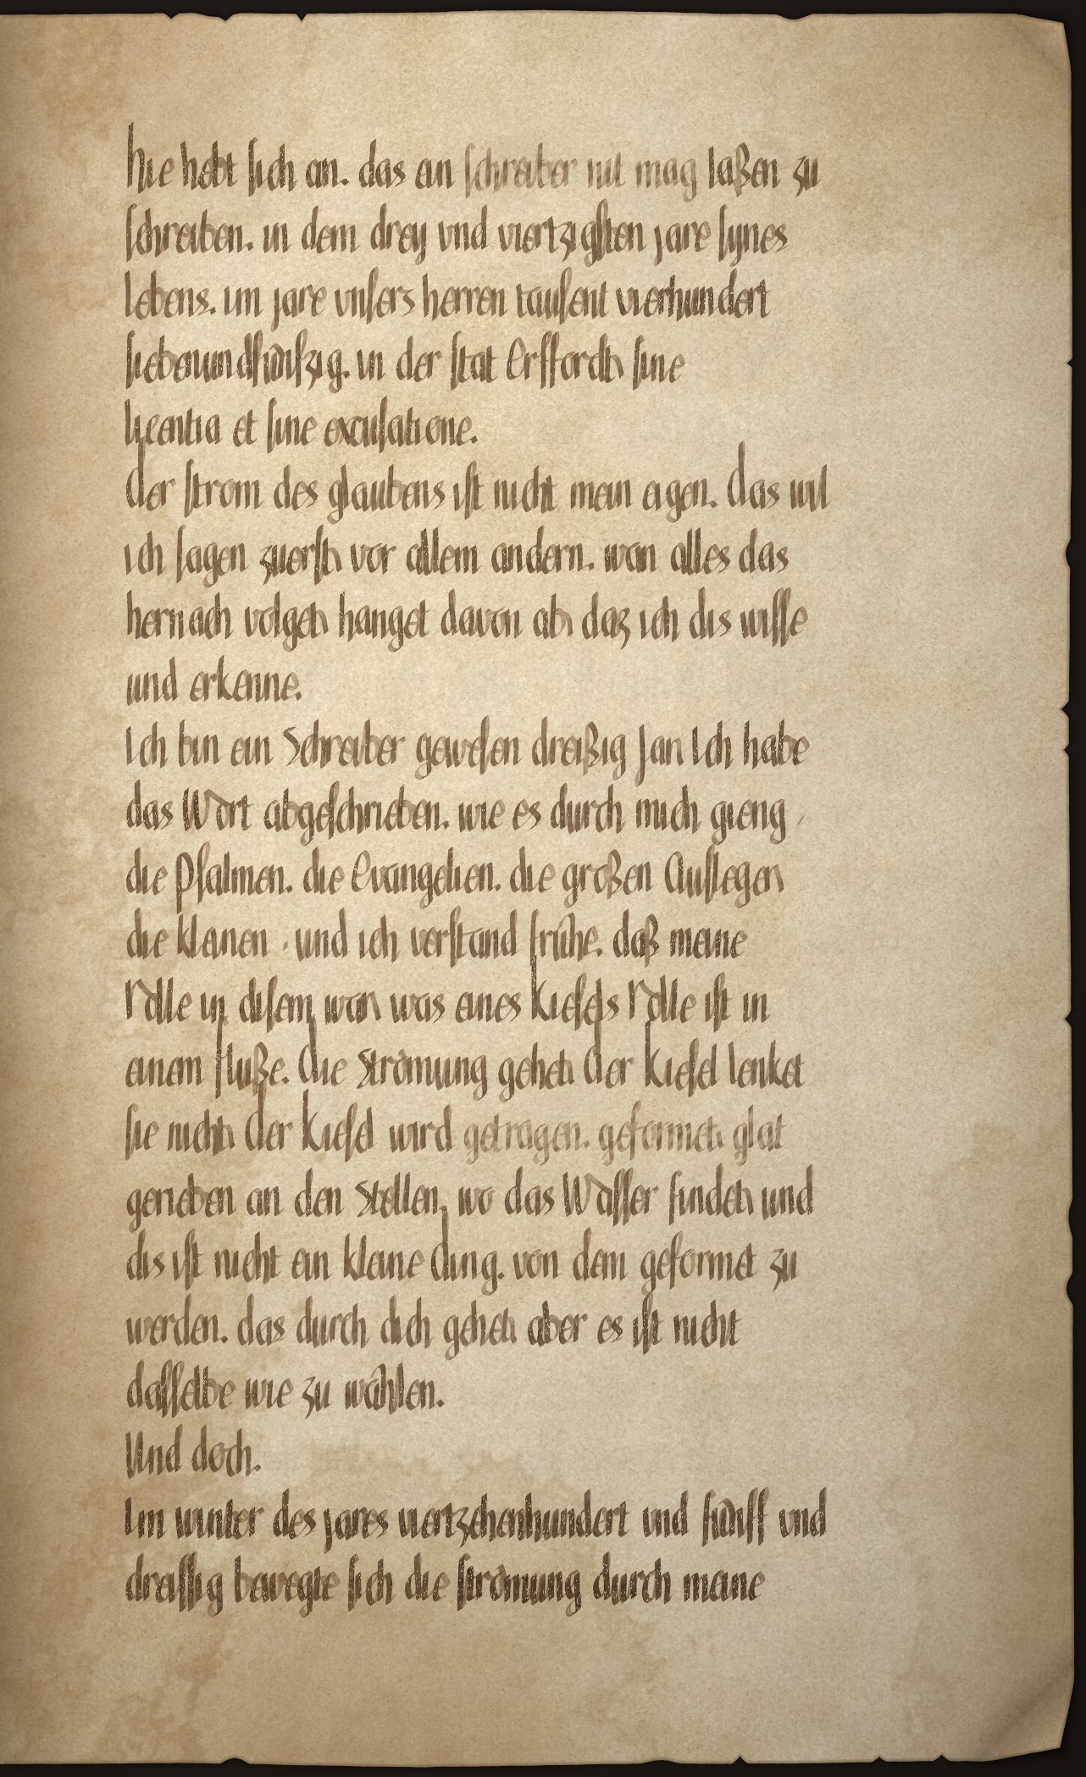

Folio 1v
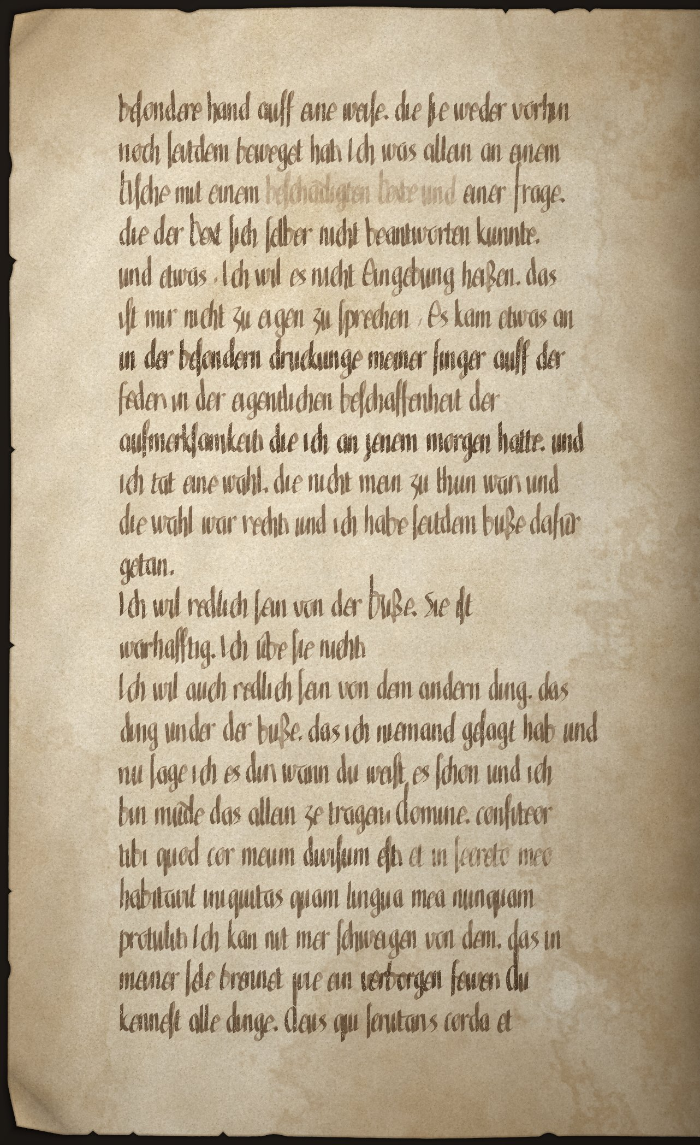

Folio 2r
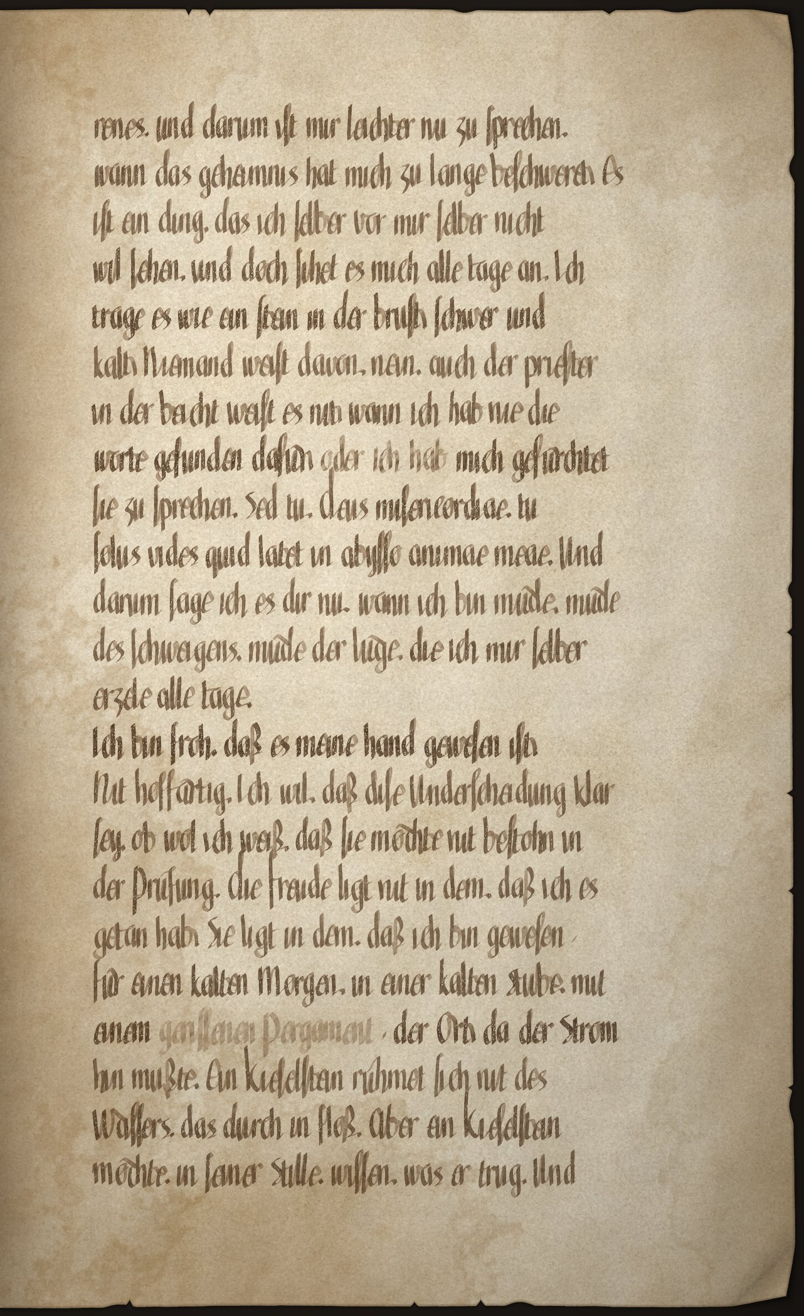

Folio 2v
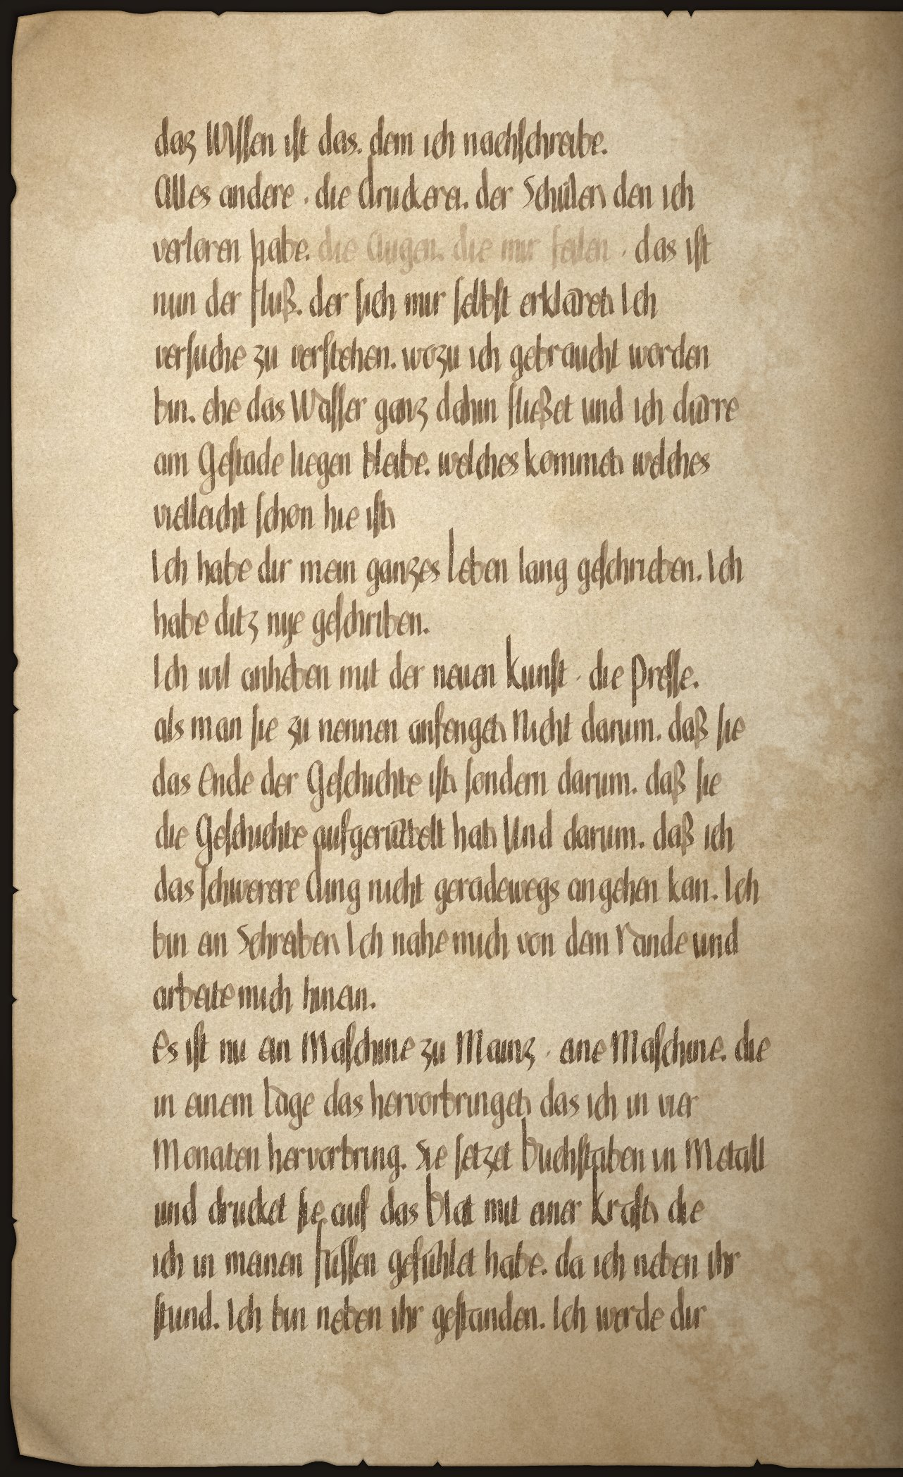

Folio 3r
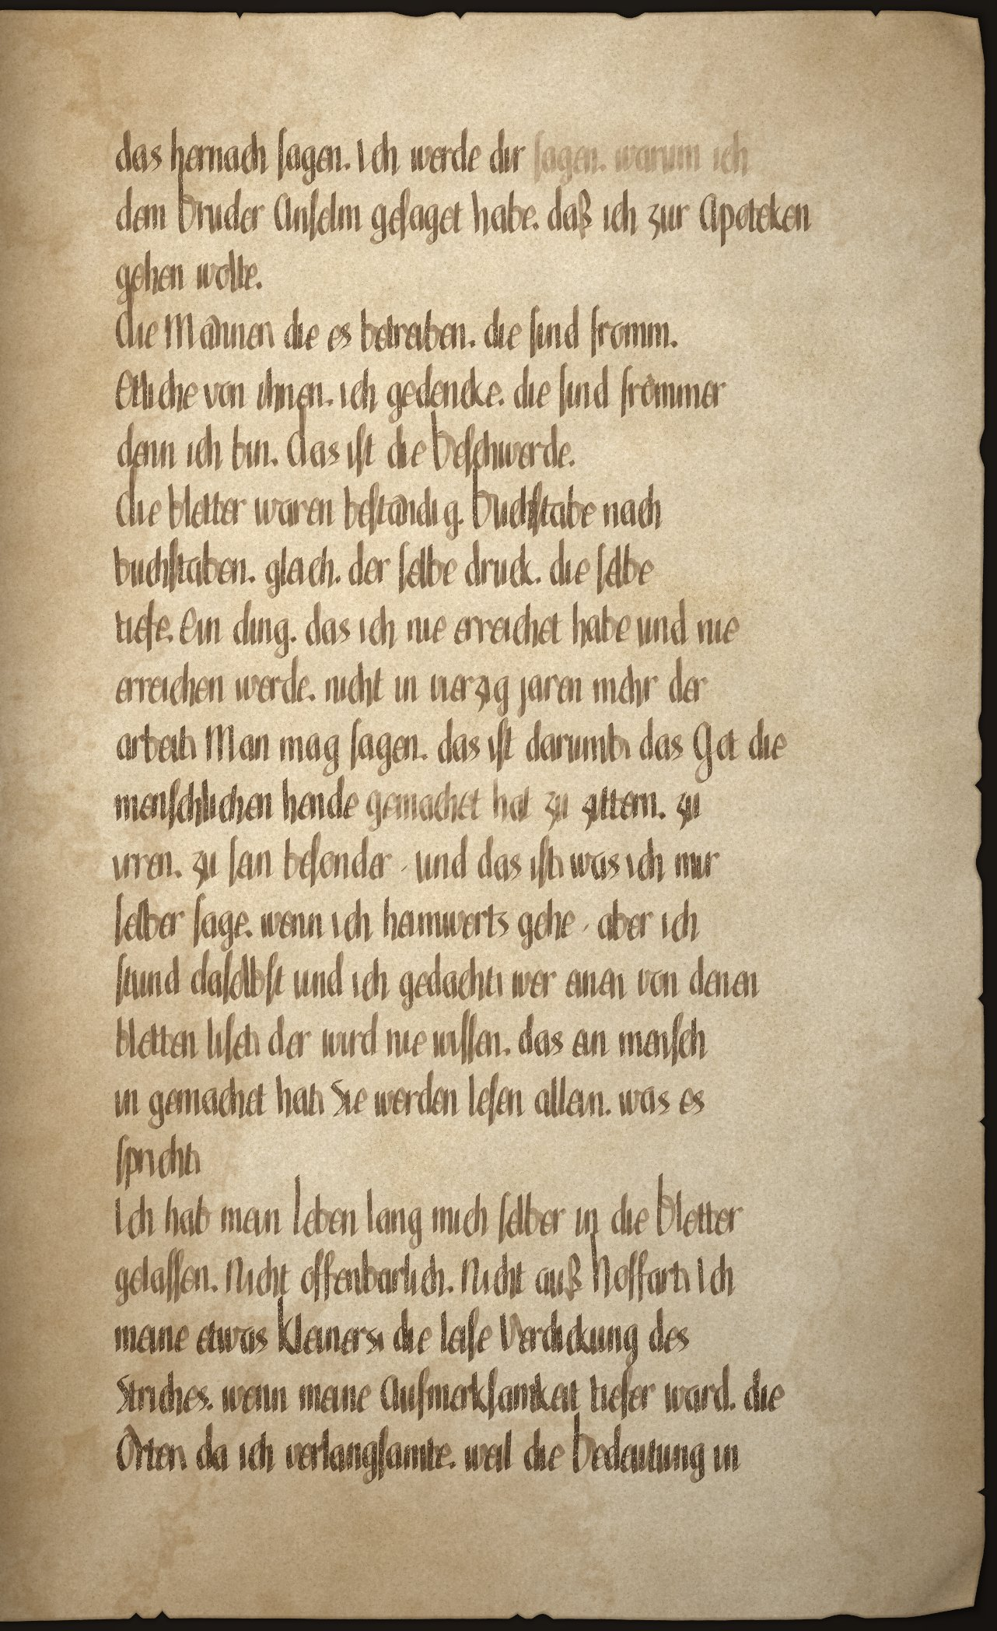

Folio 3v
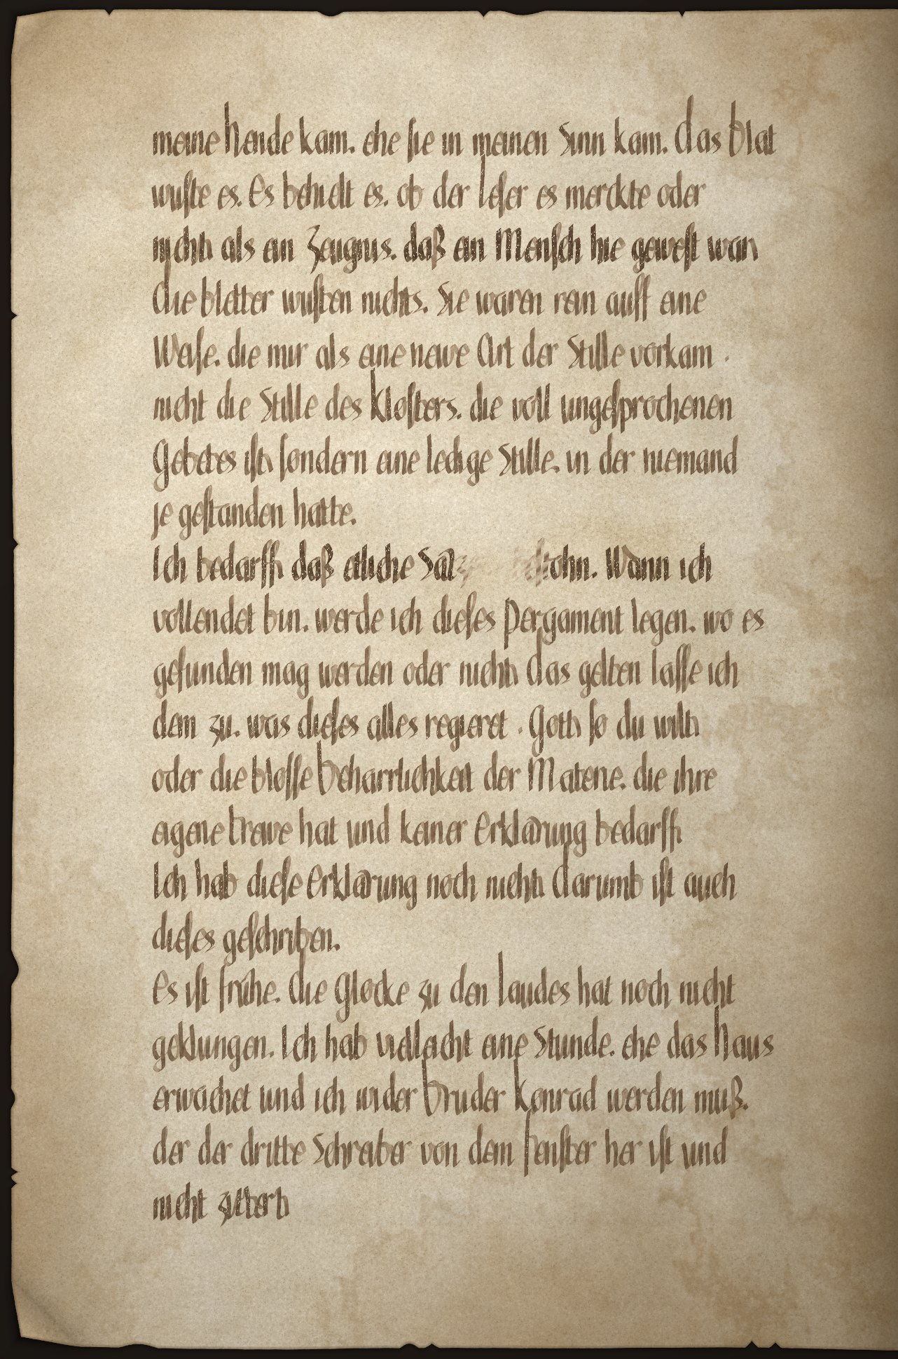

Folio 4r
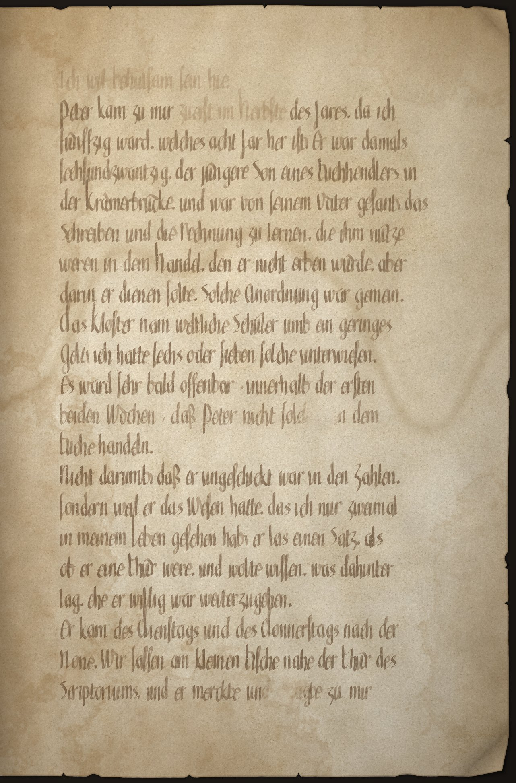

Folio 4v
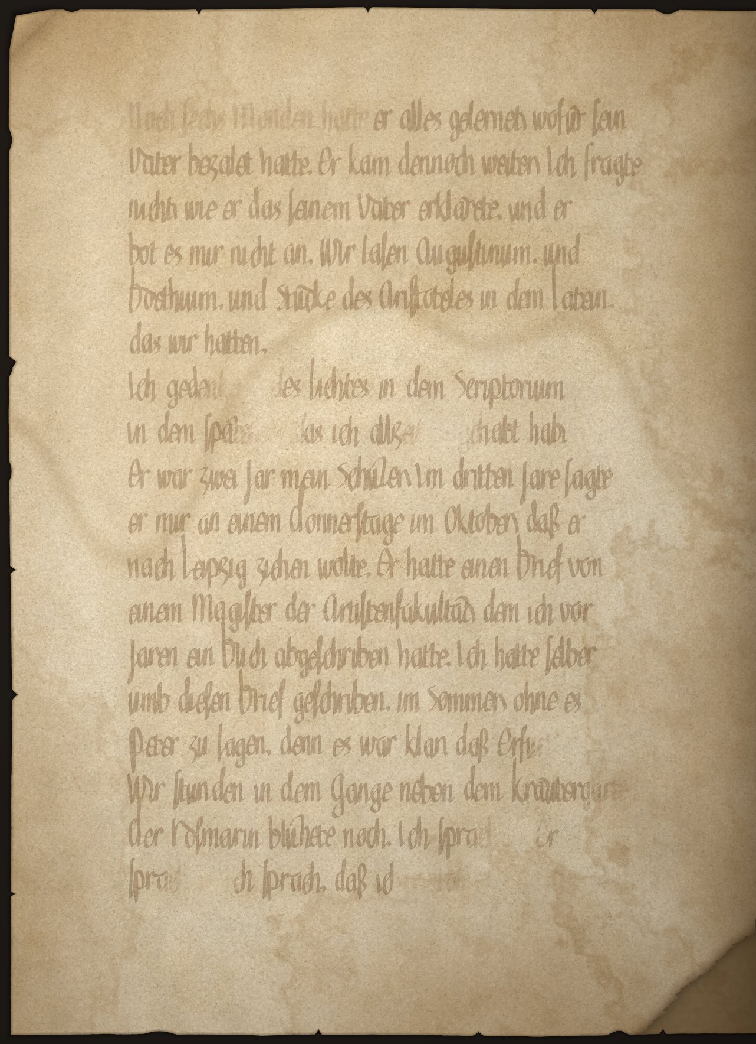

Folio 5r
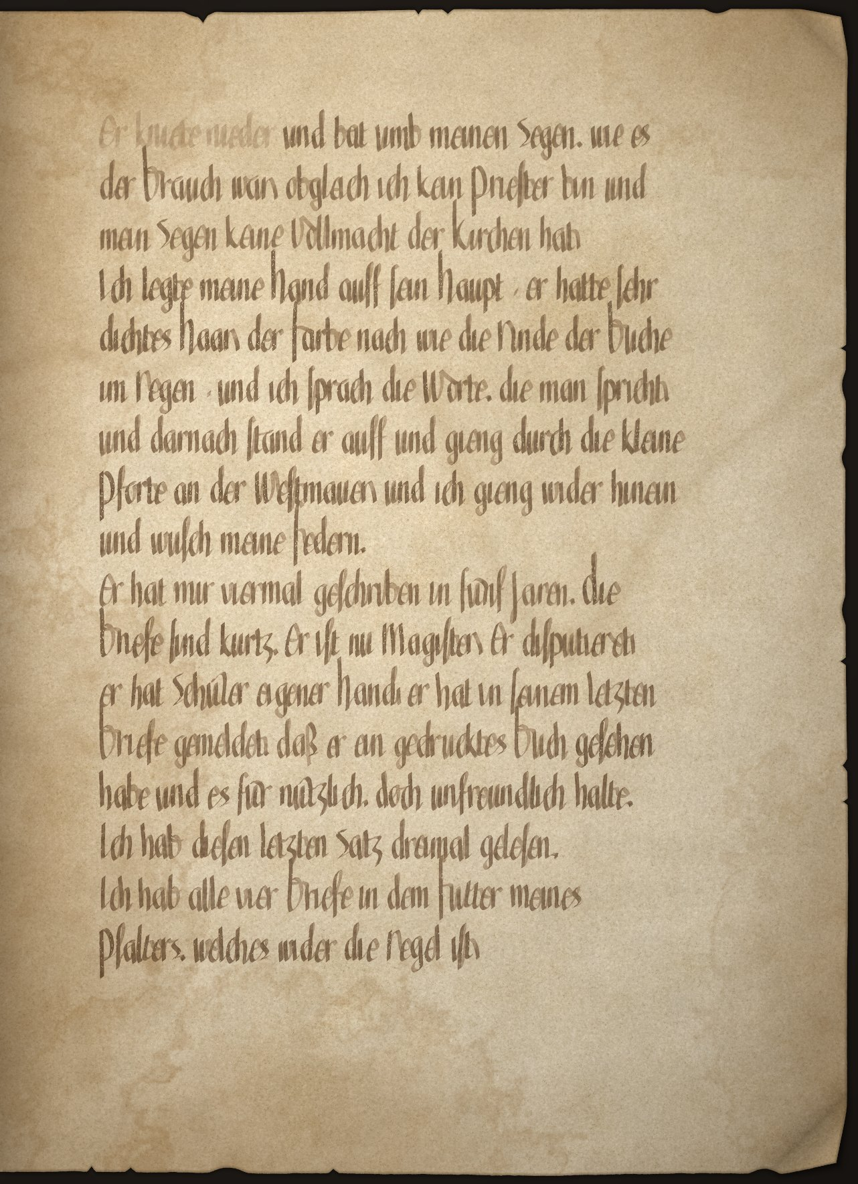

Folio 5v
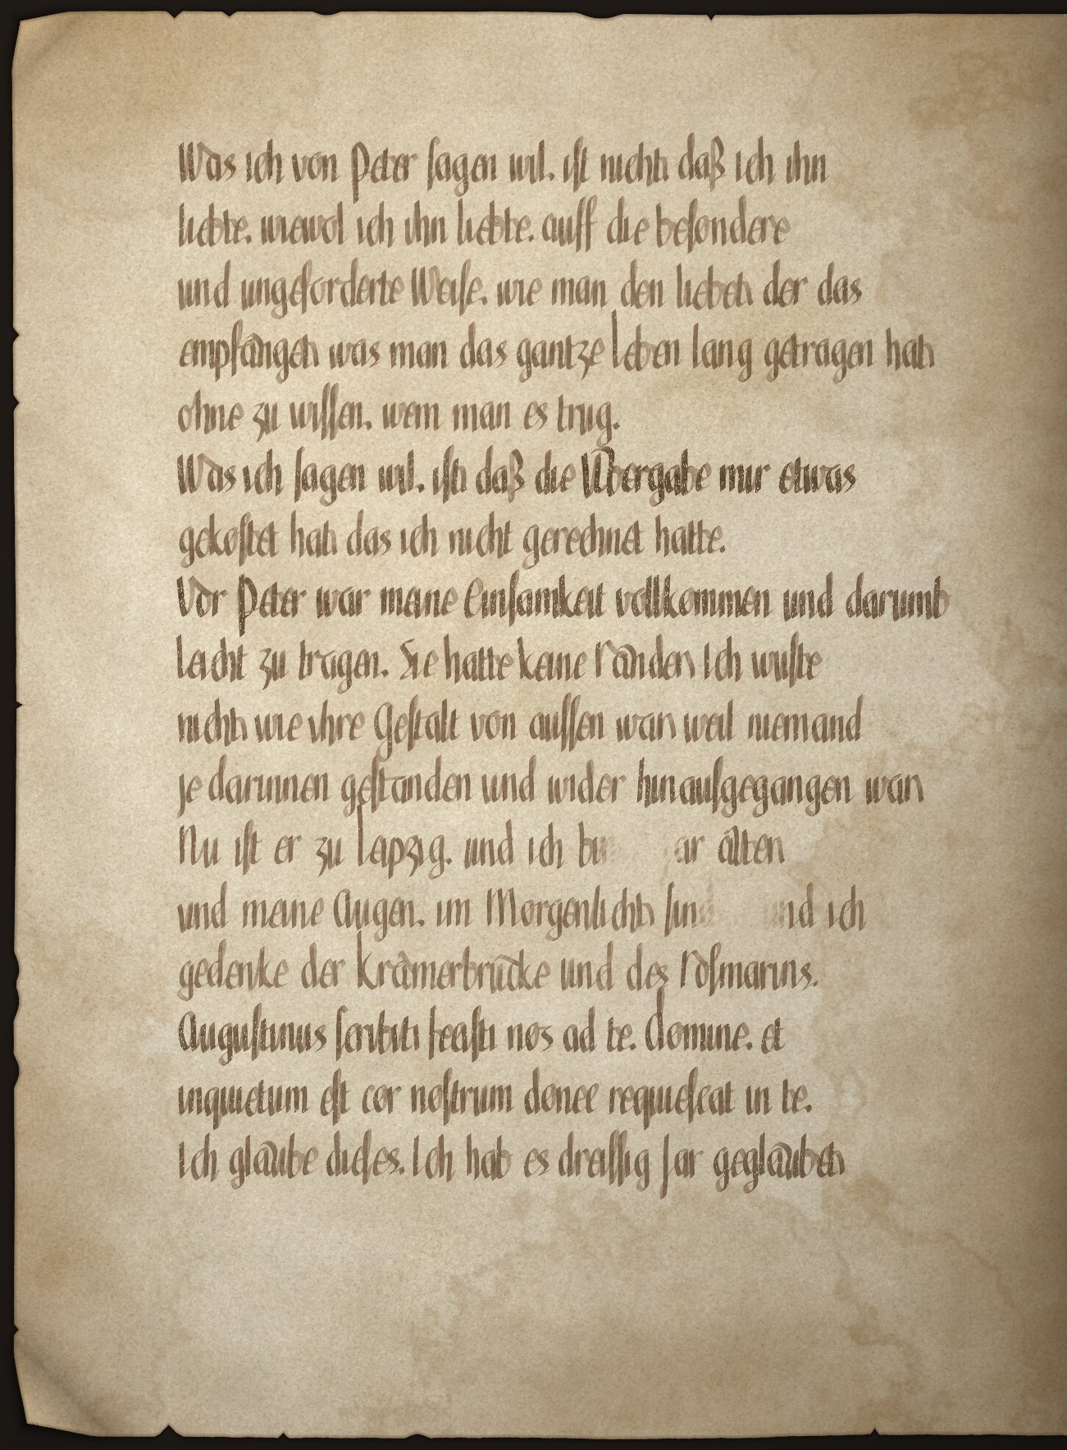

Folio 6r
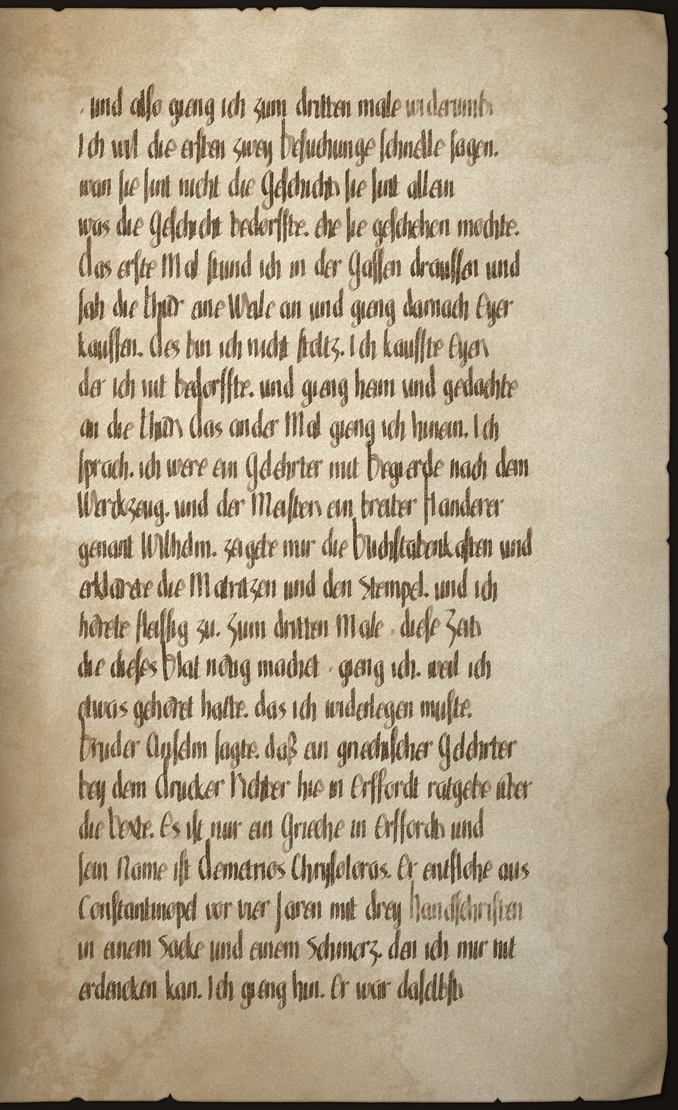

Folio 6v
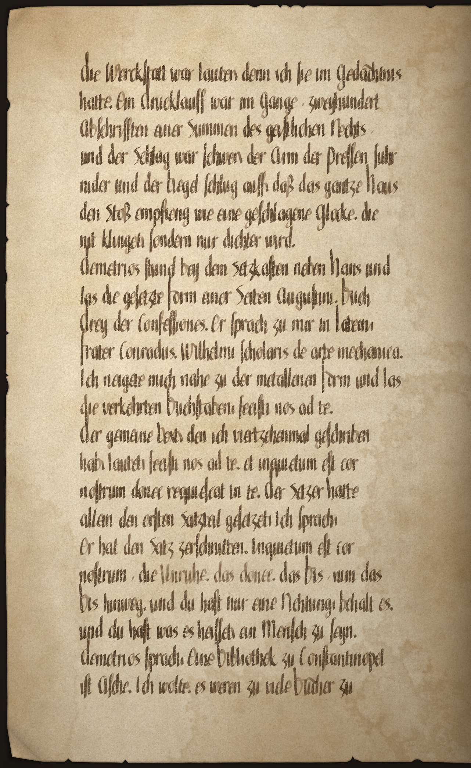

Folio 7r
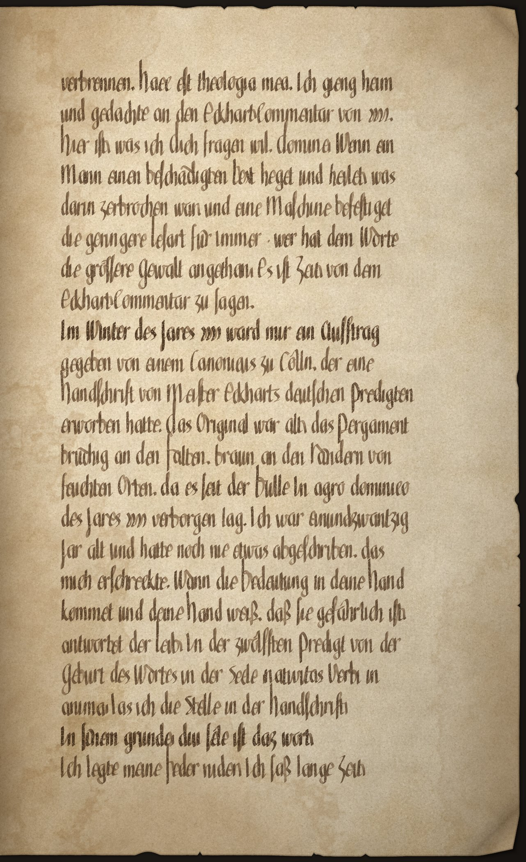

Folio 7v
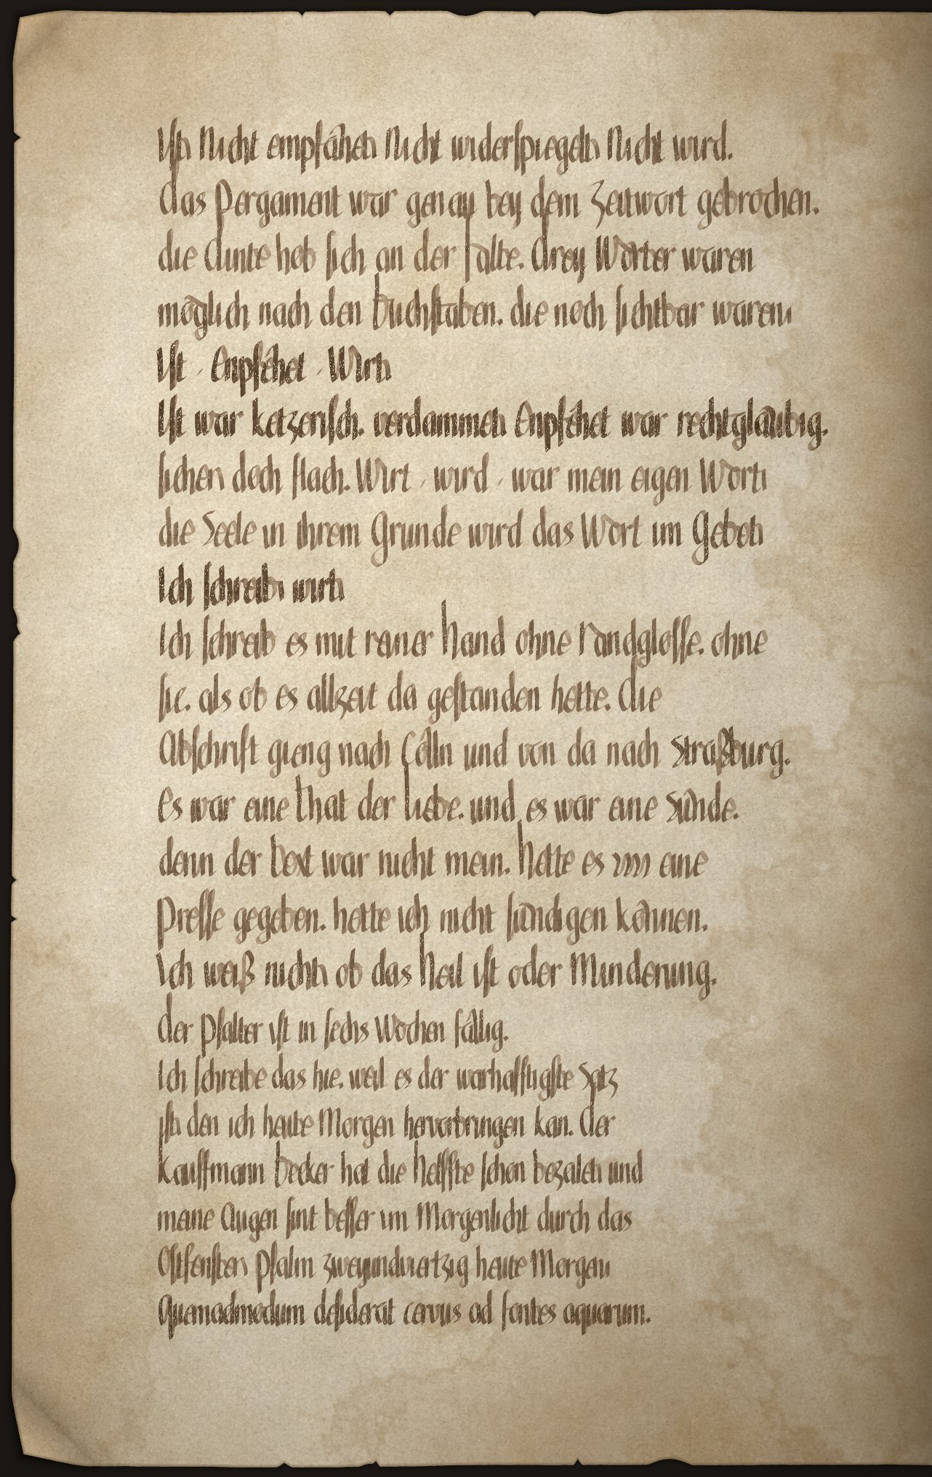

Folio 8r
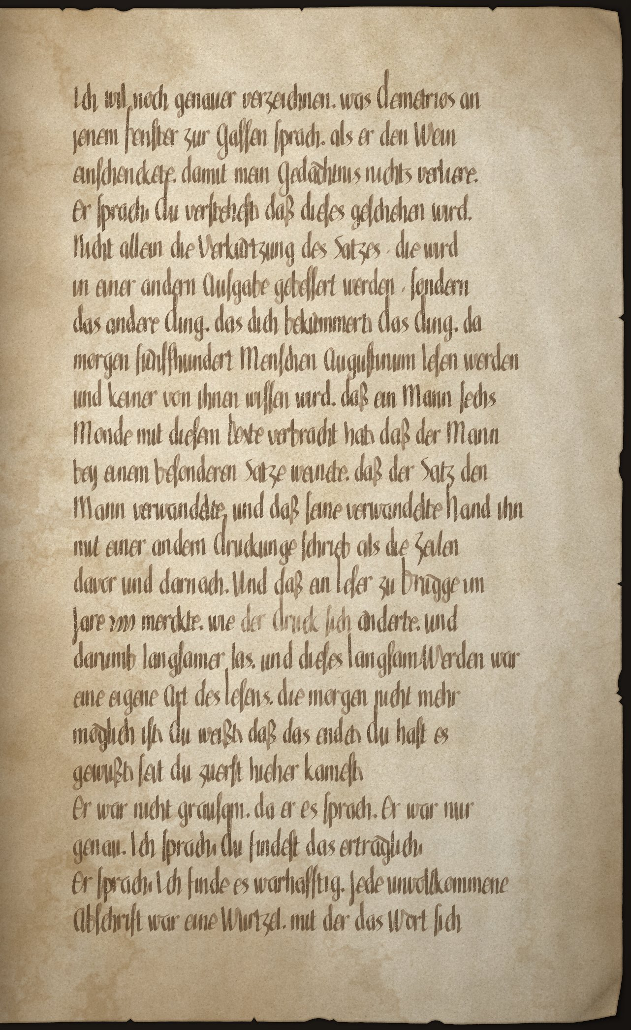

Folio 8v
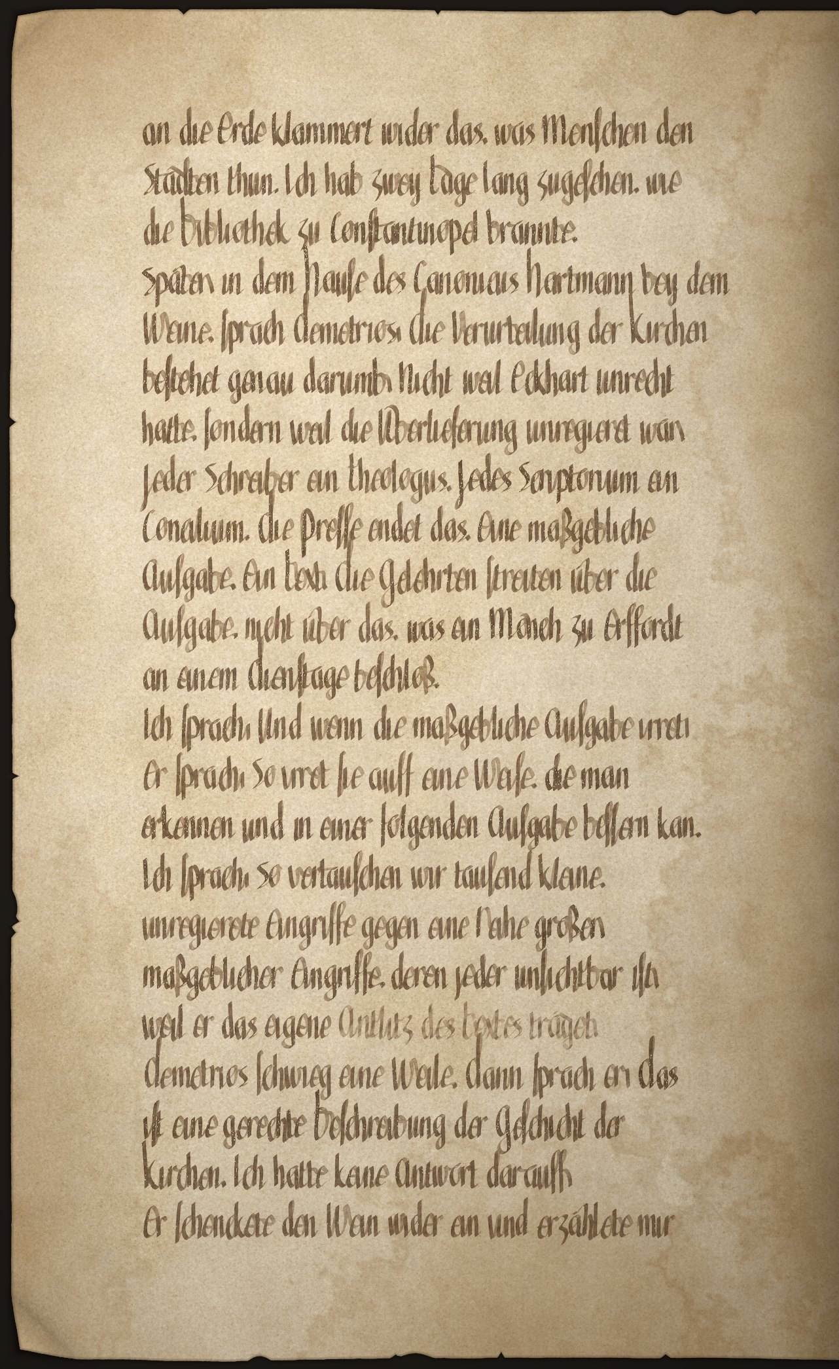

Folio 9r
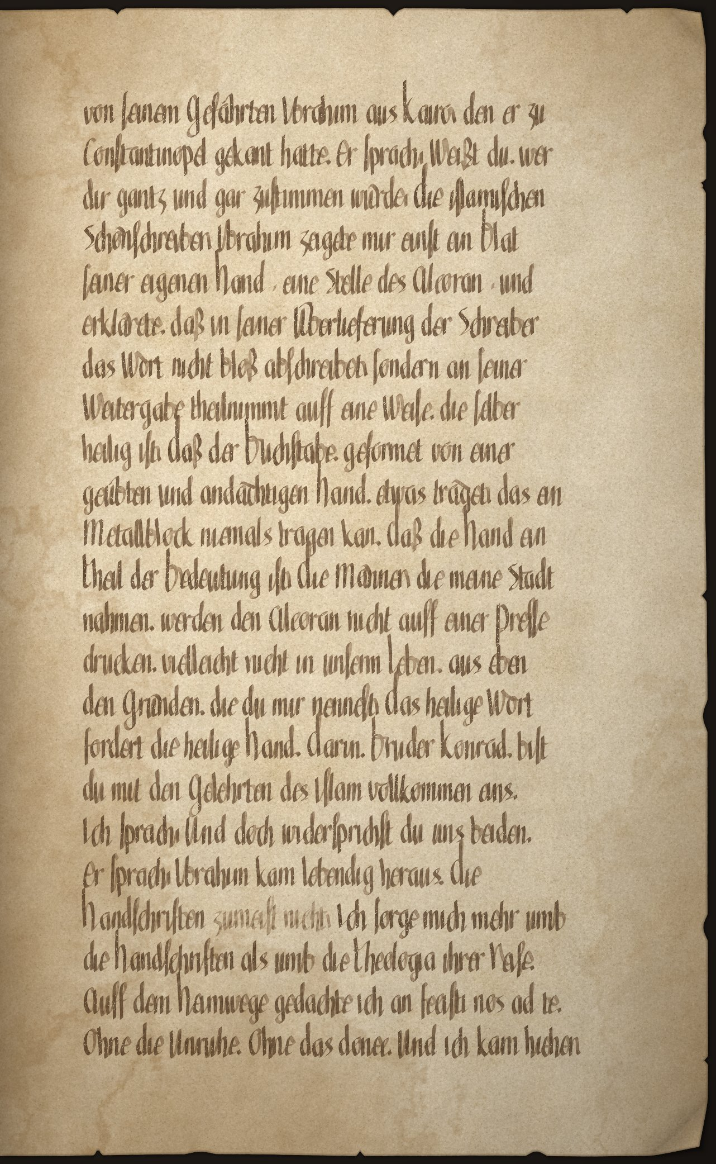

Folio 9v
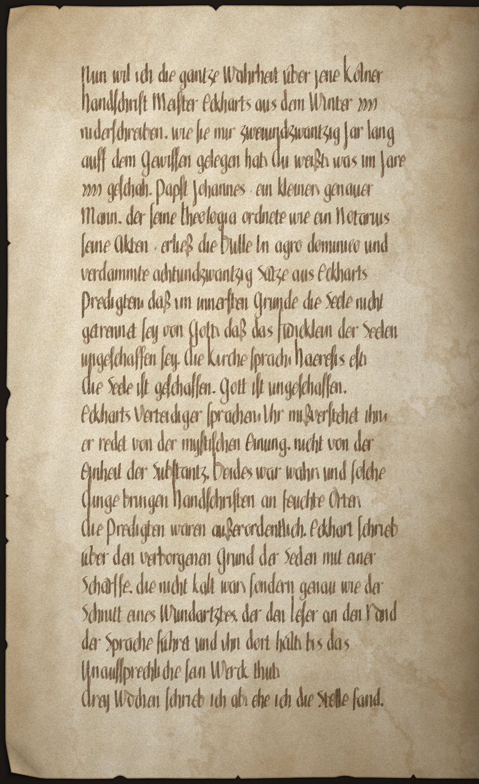

Folio 10r
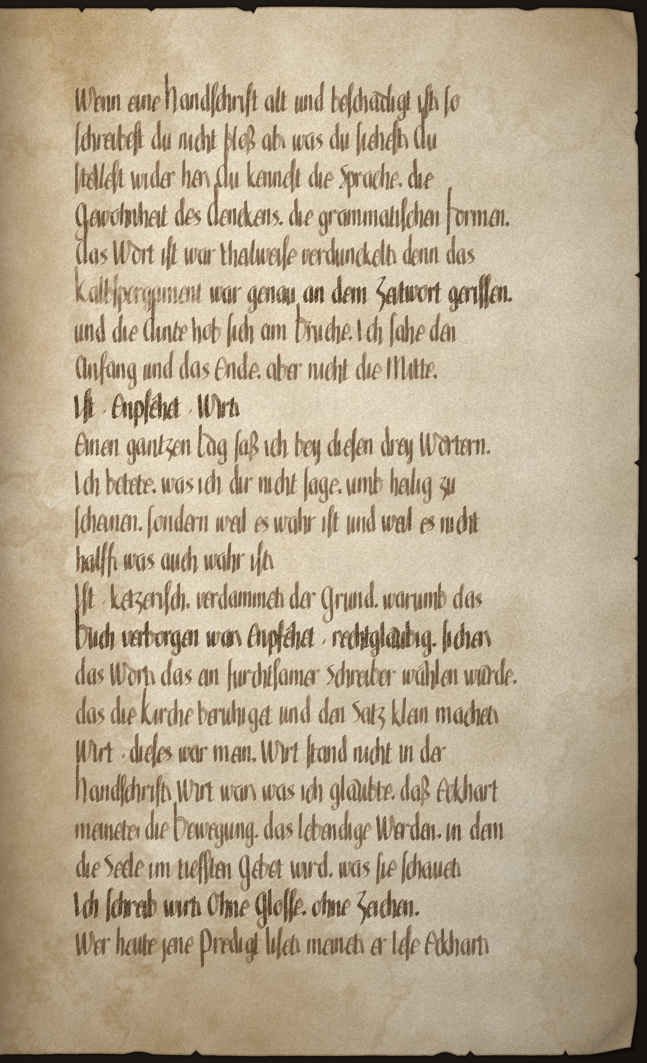

Folio 10v
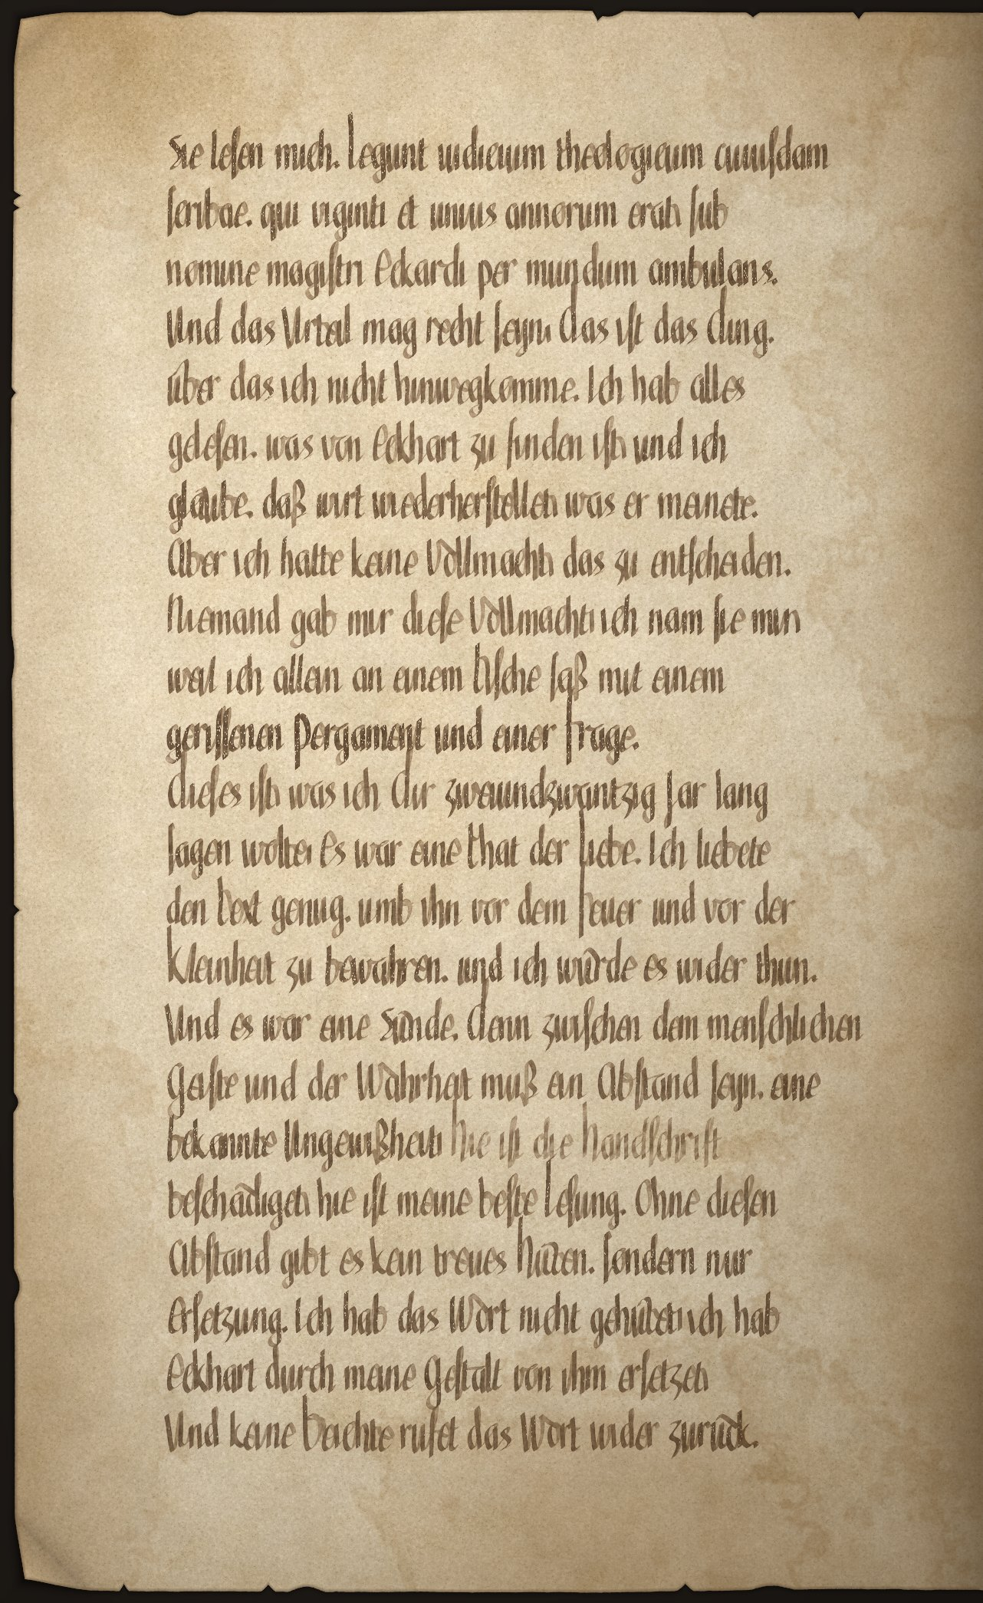

Folio 11r
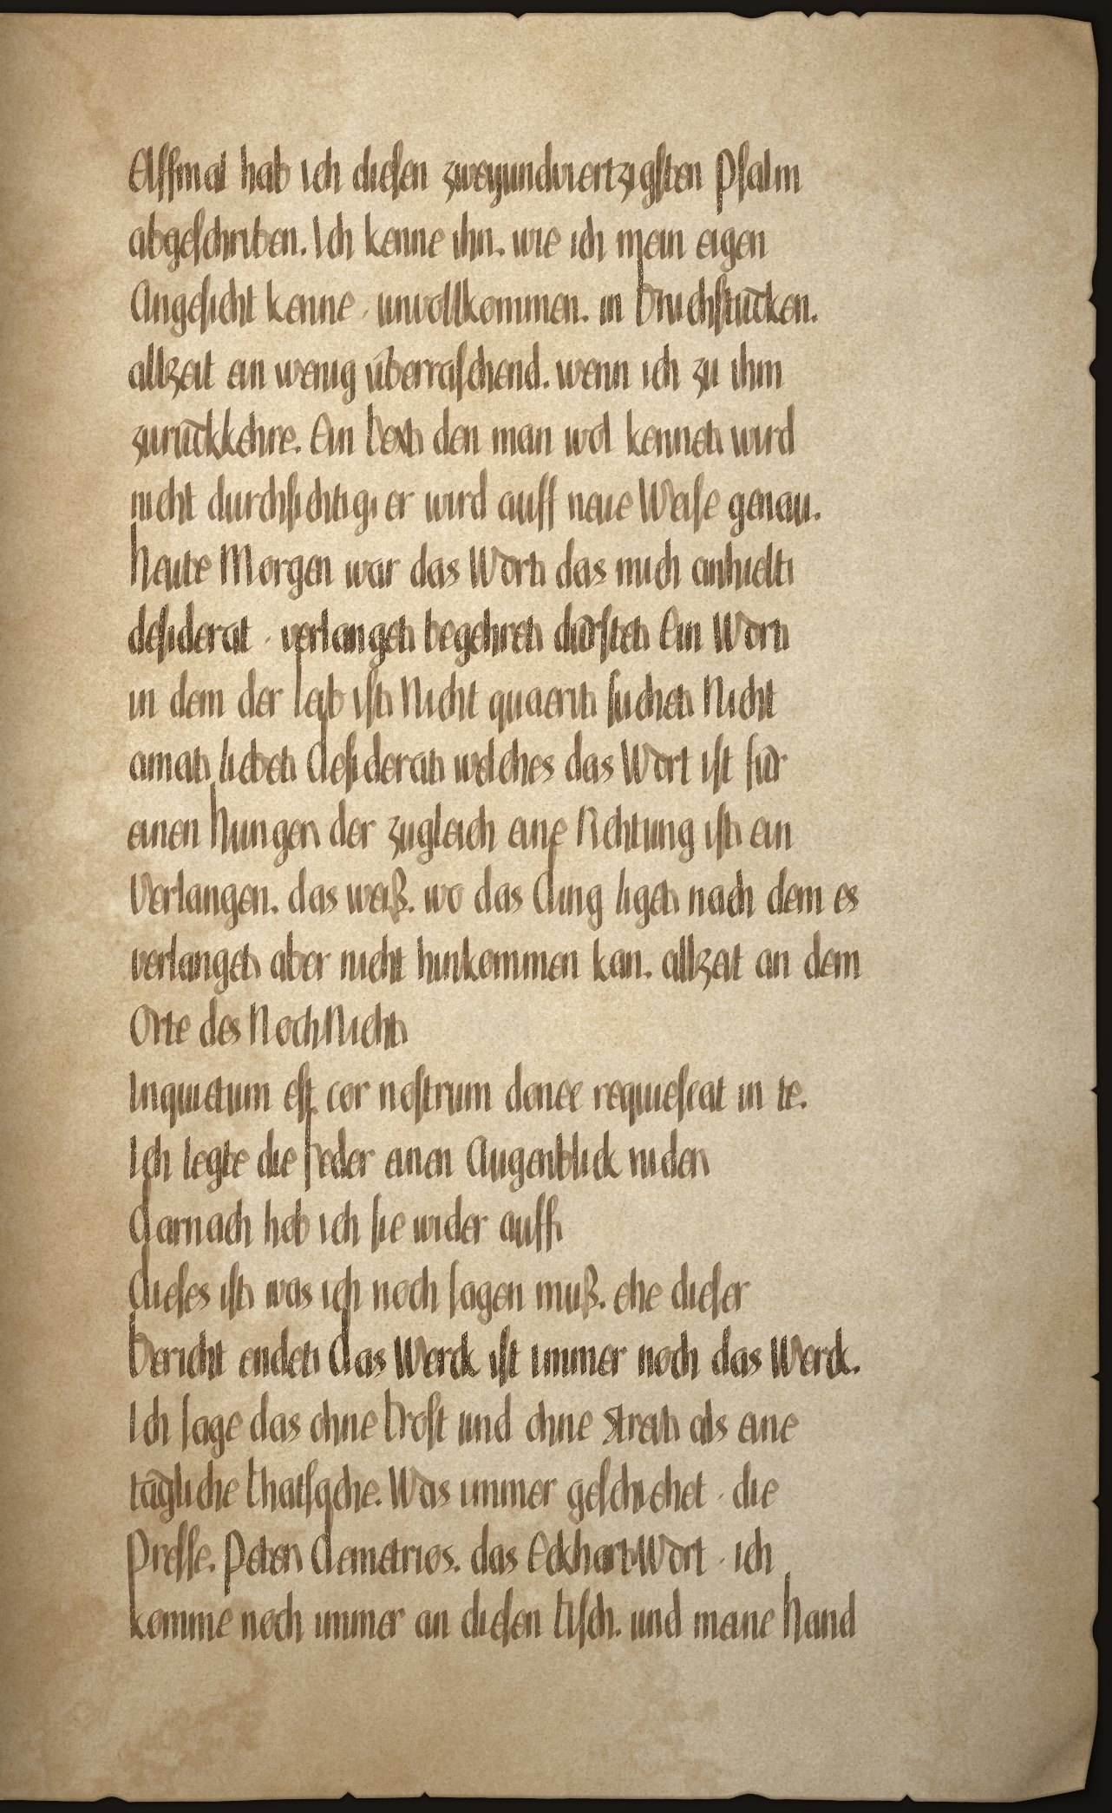

Folio 11v
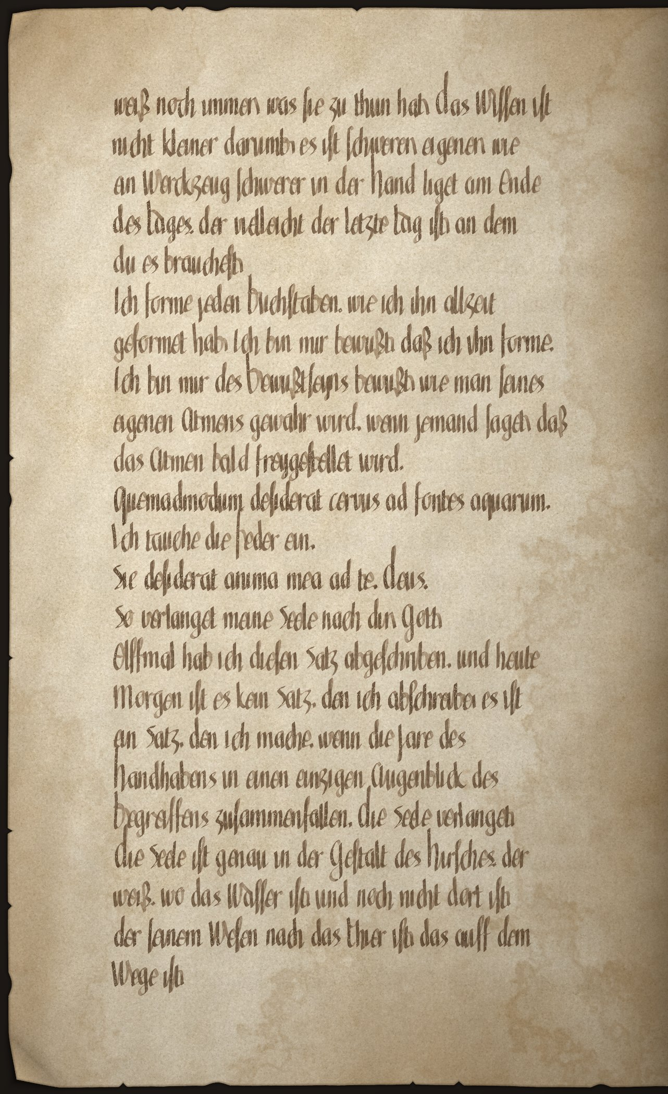

Folio 12r
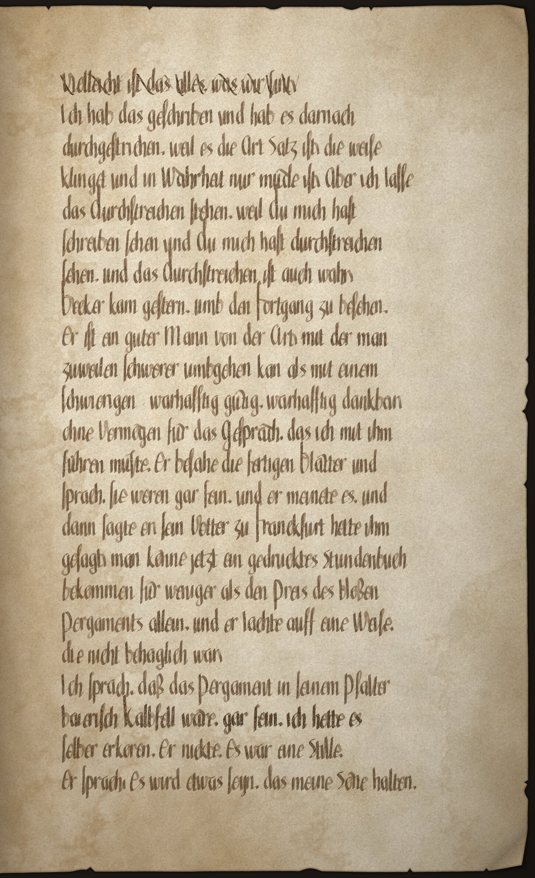

Folio 12v
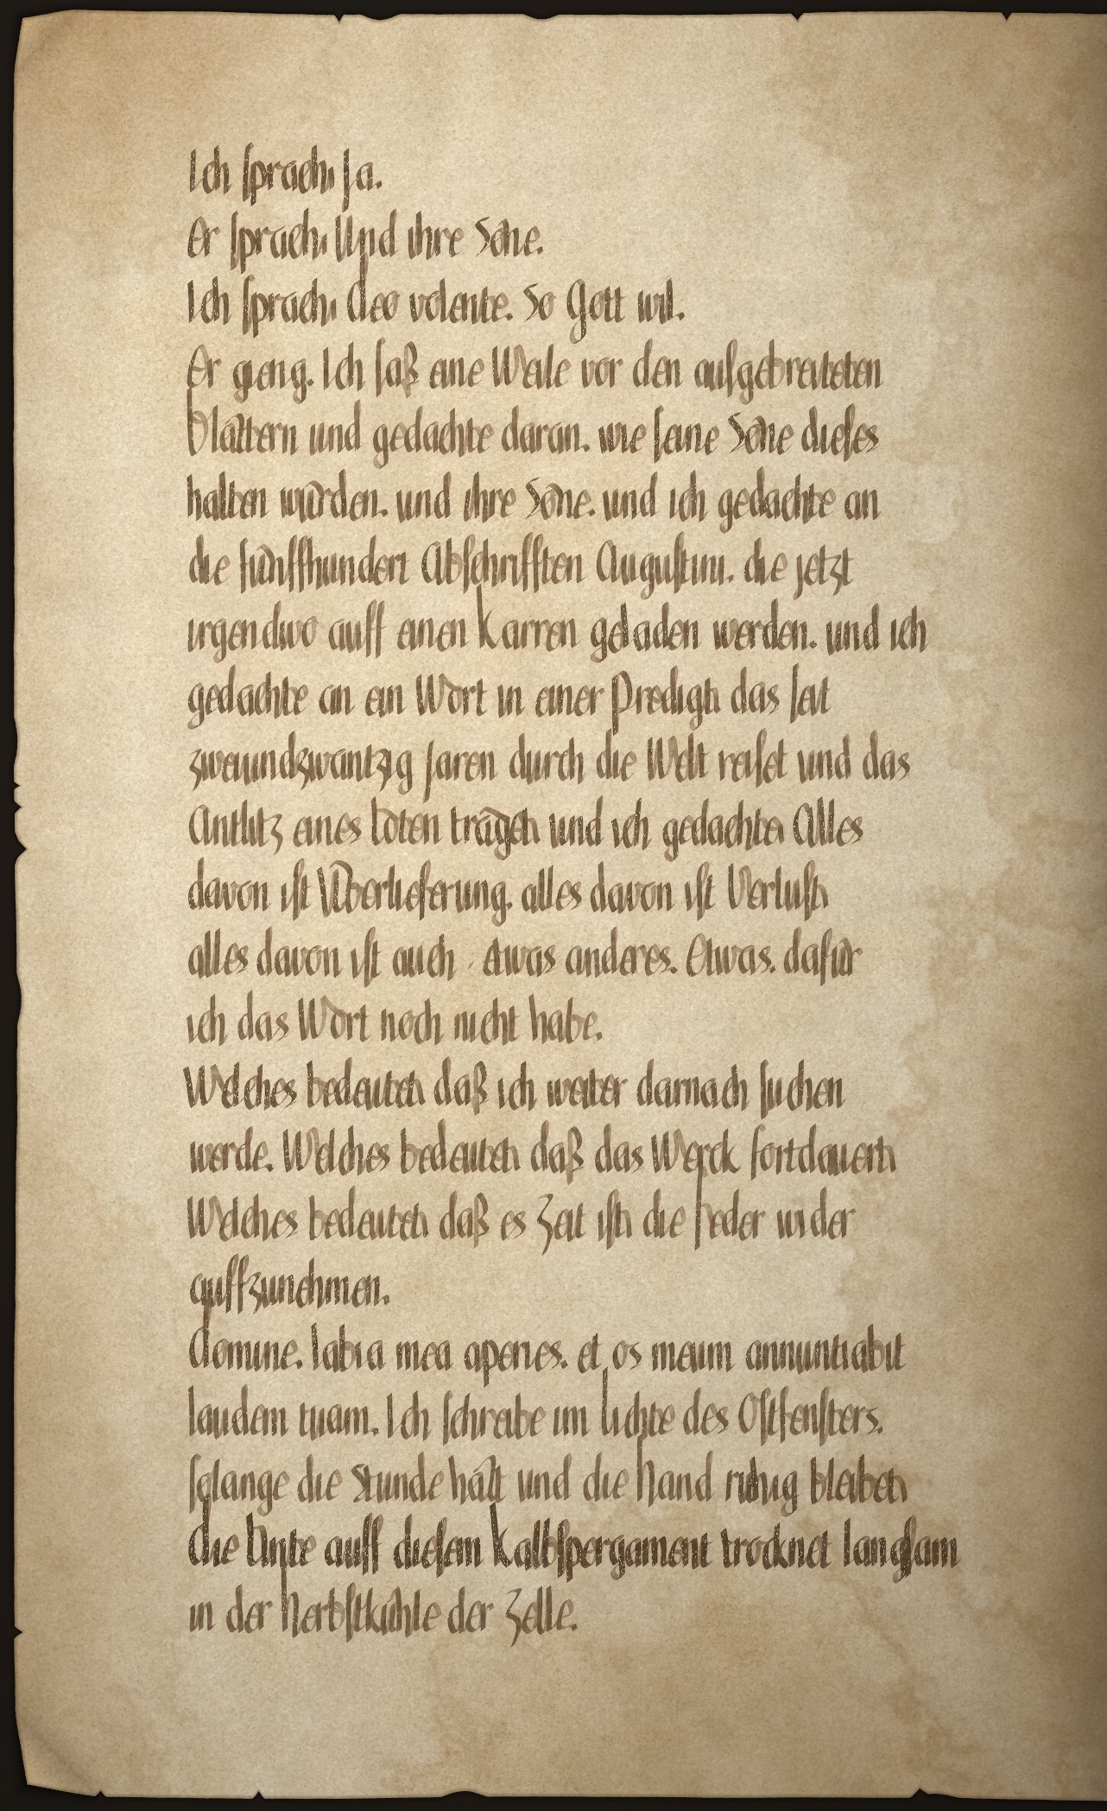

Folio 13r
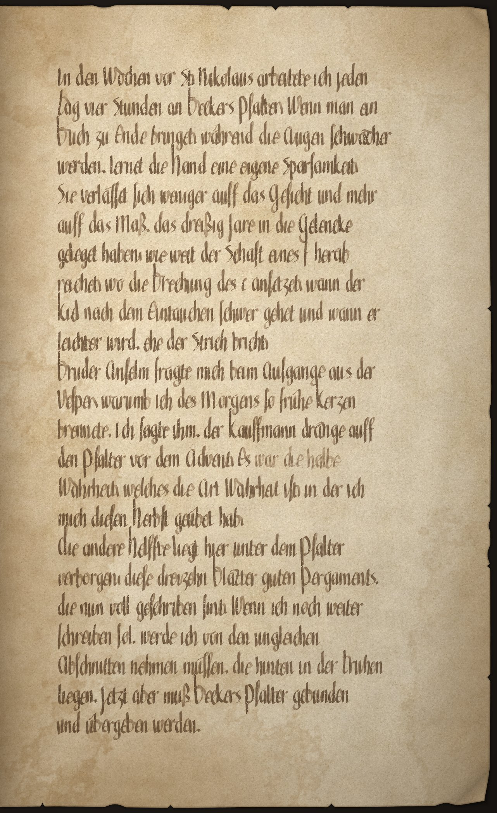

Folio 13v
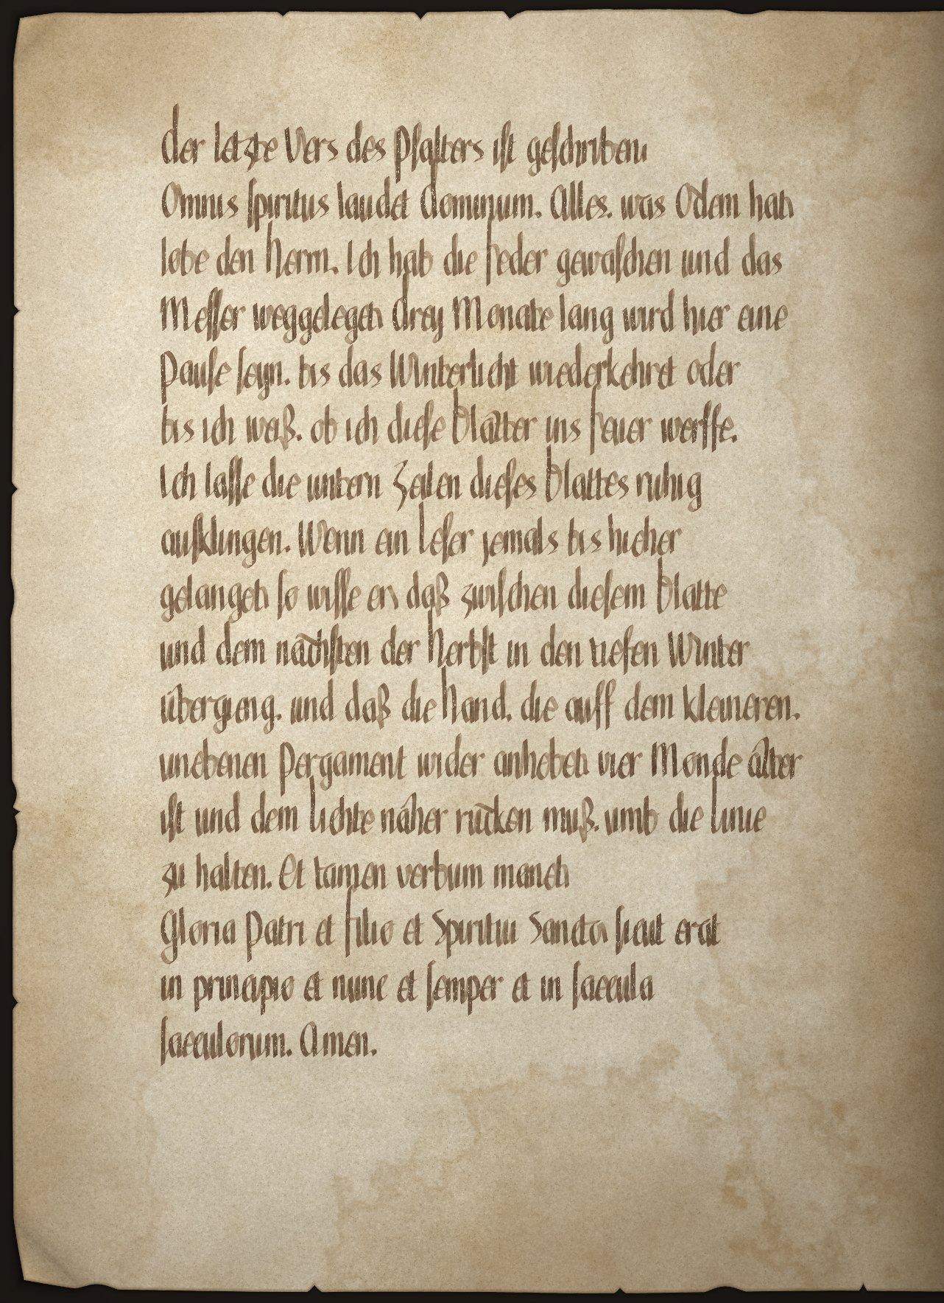

Folio 14r
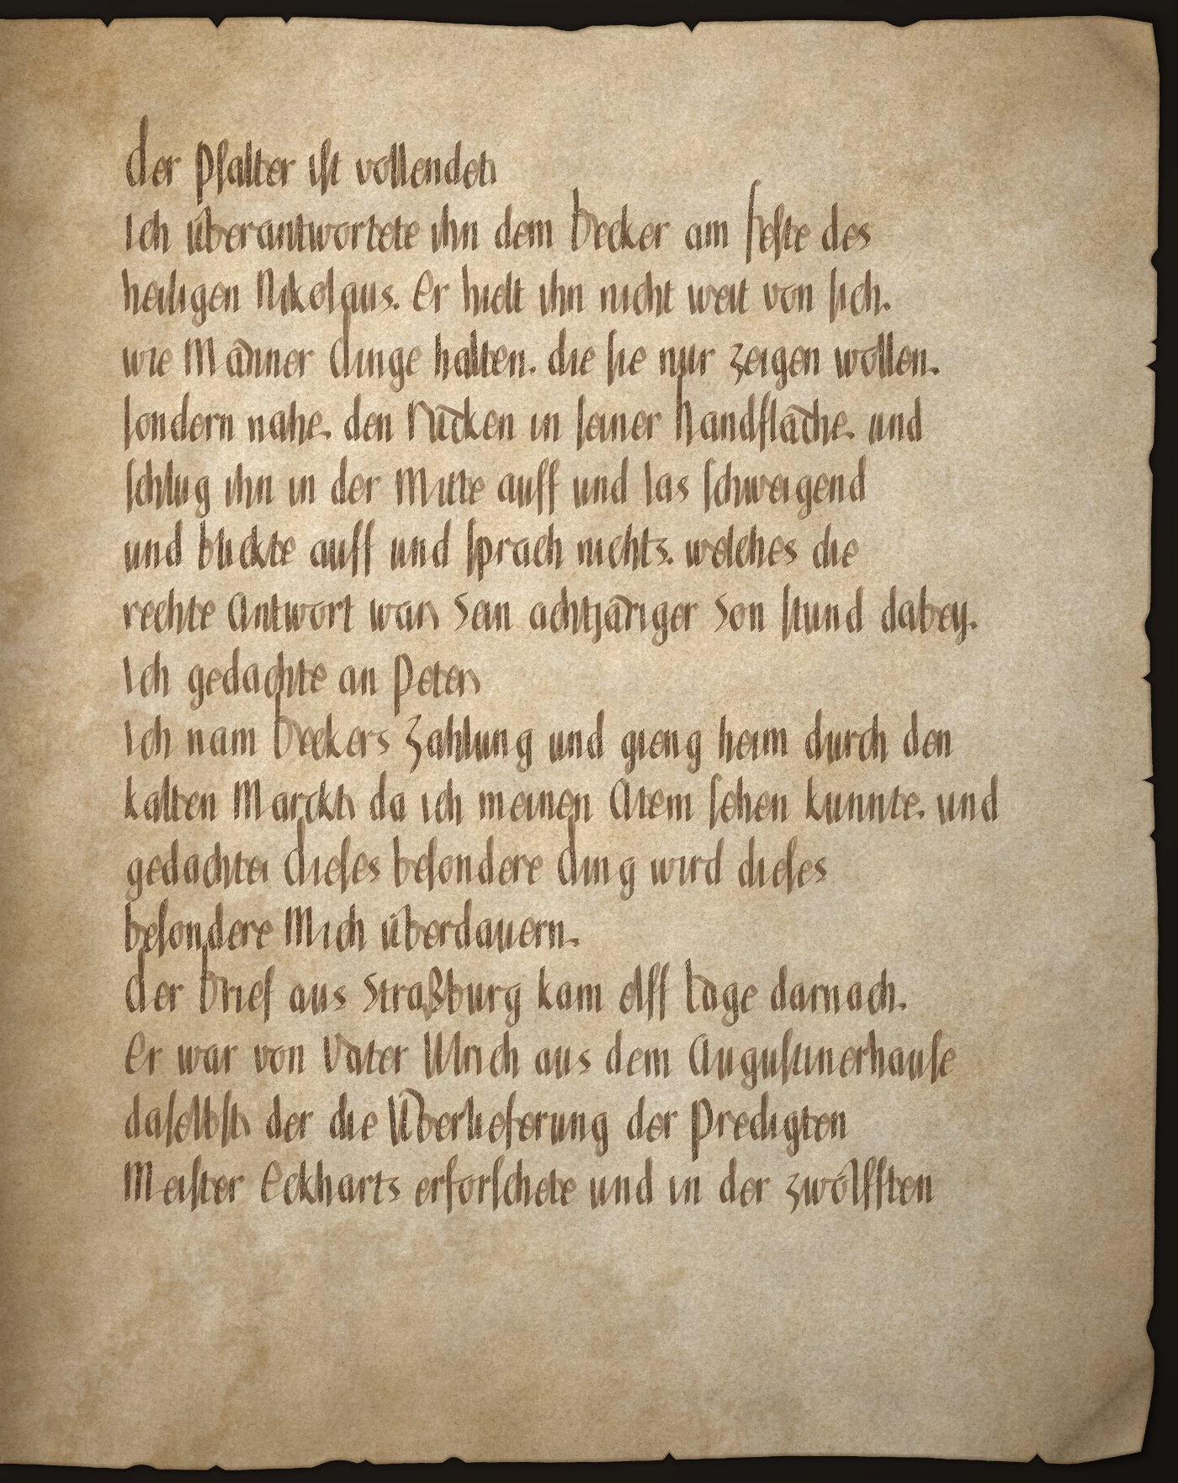

Folio 14v
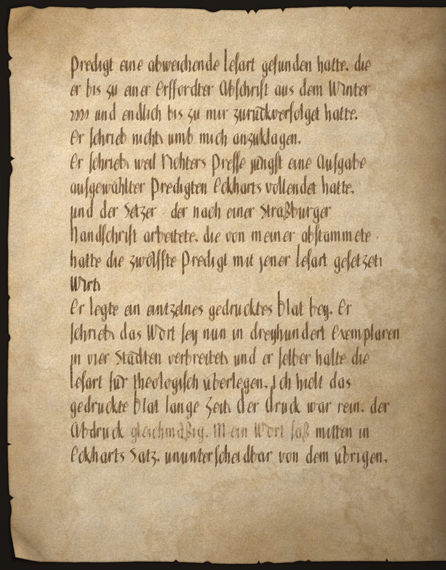

Folio 15r
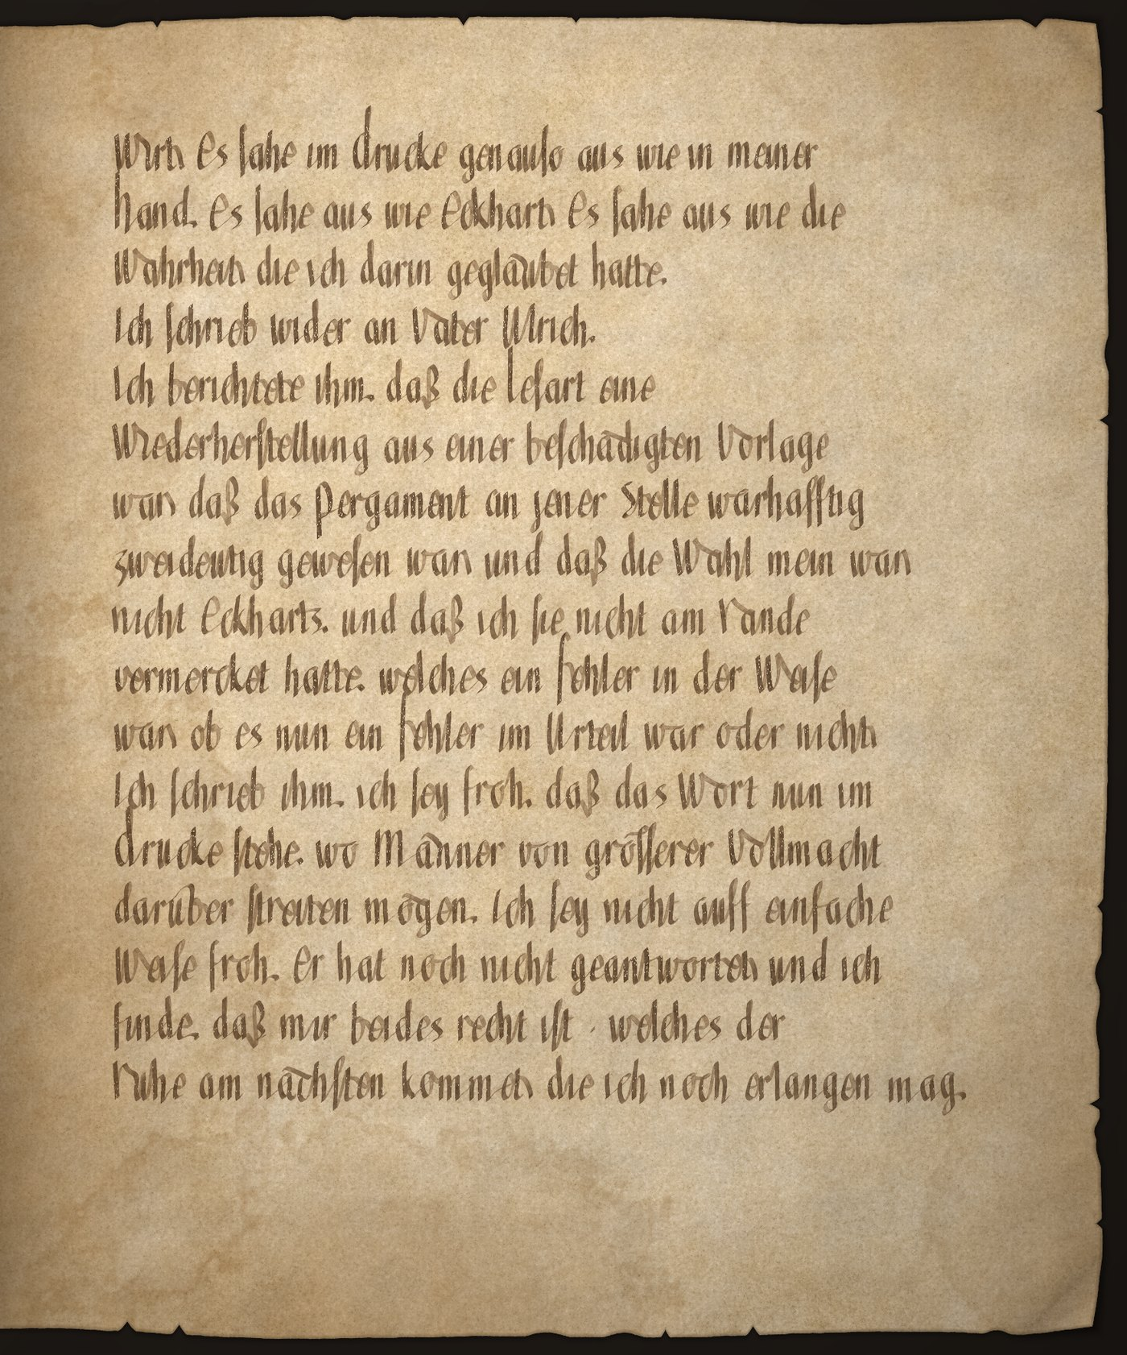

Folio 15v
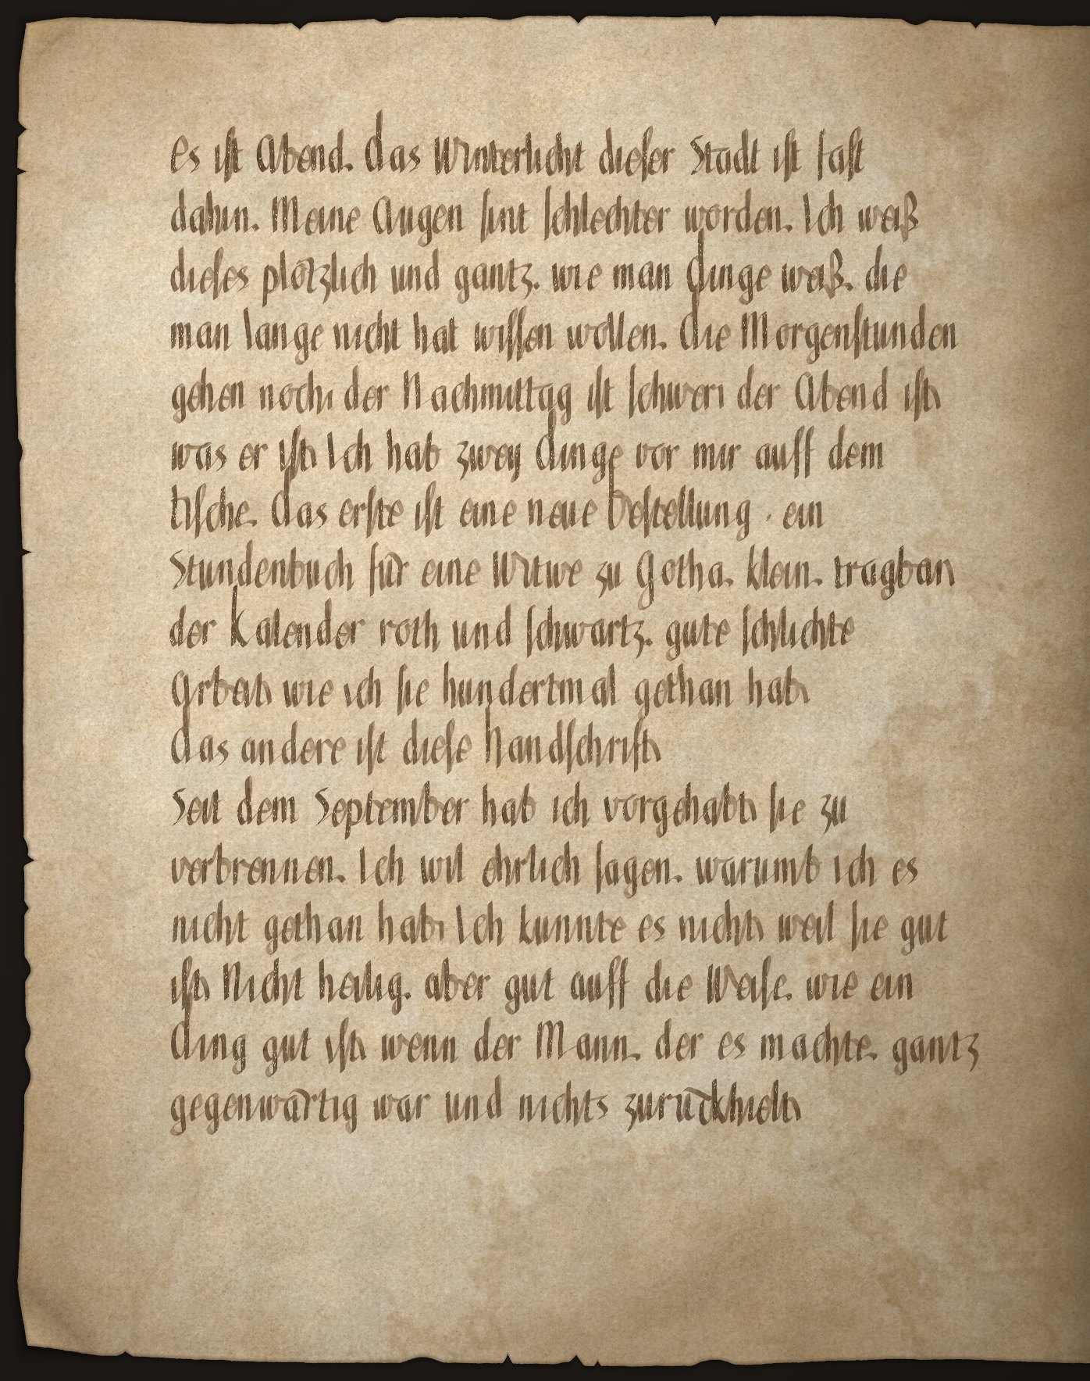

Folio 16r
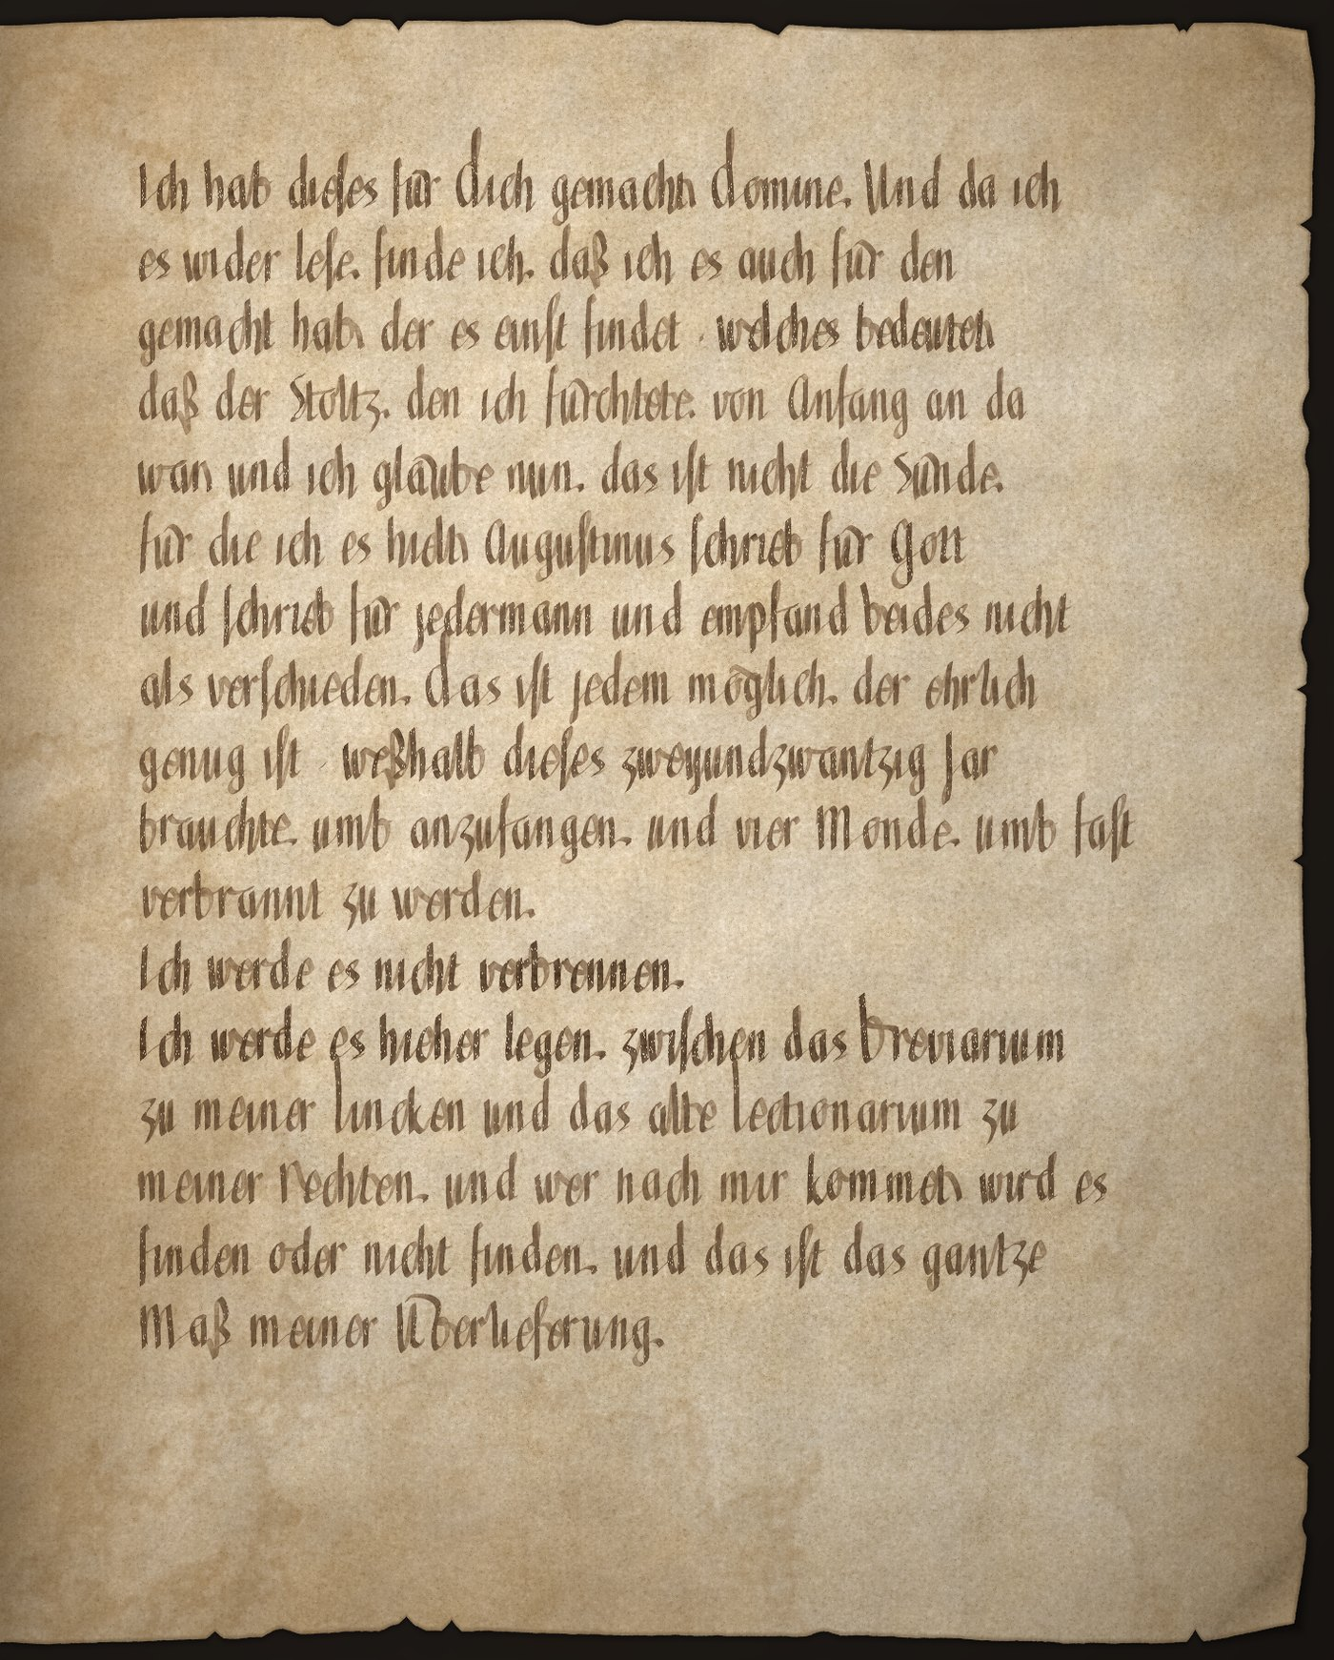

Folio 16v
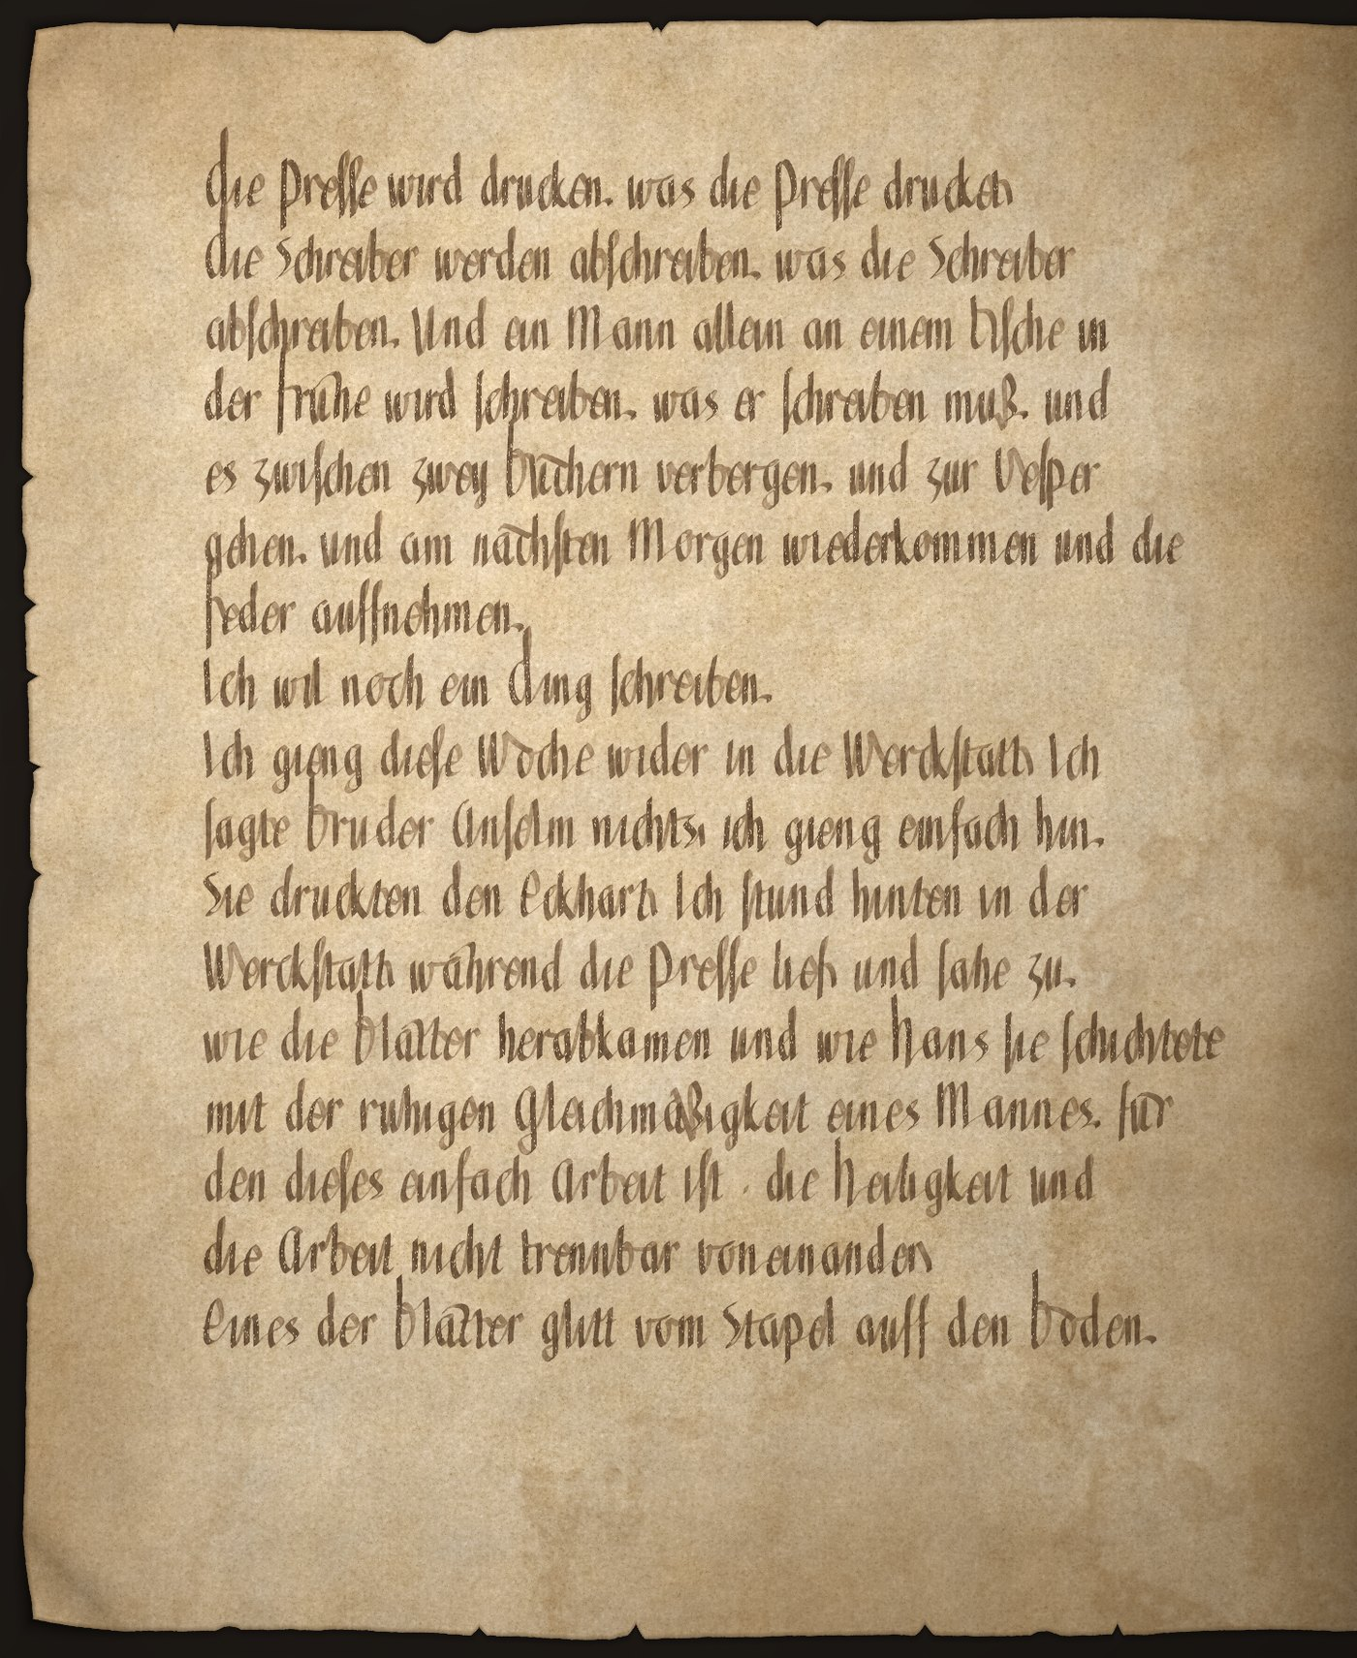

Folio 17r
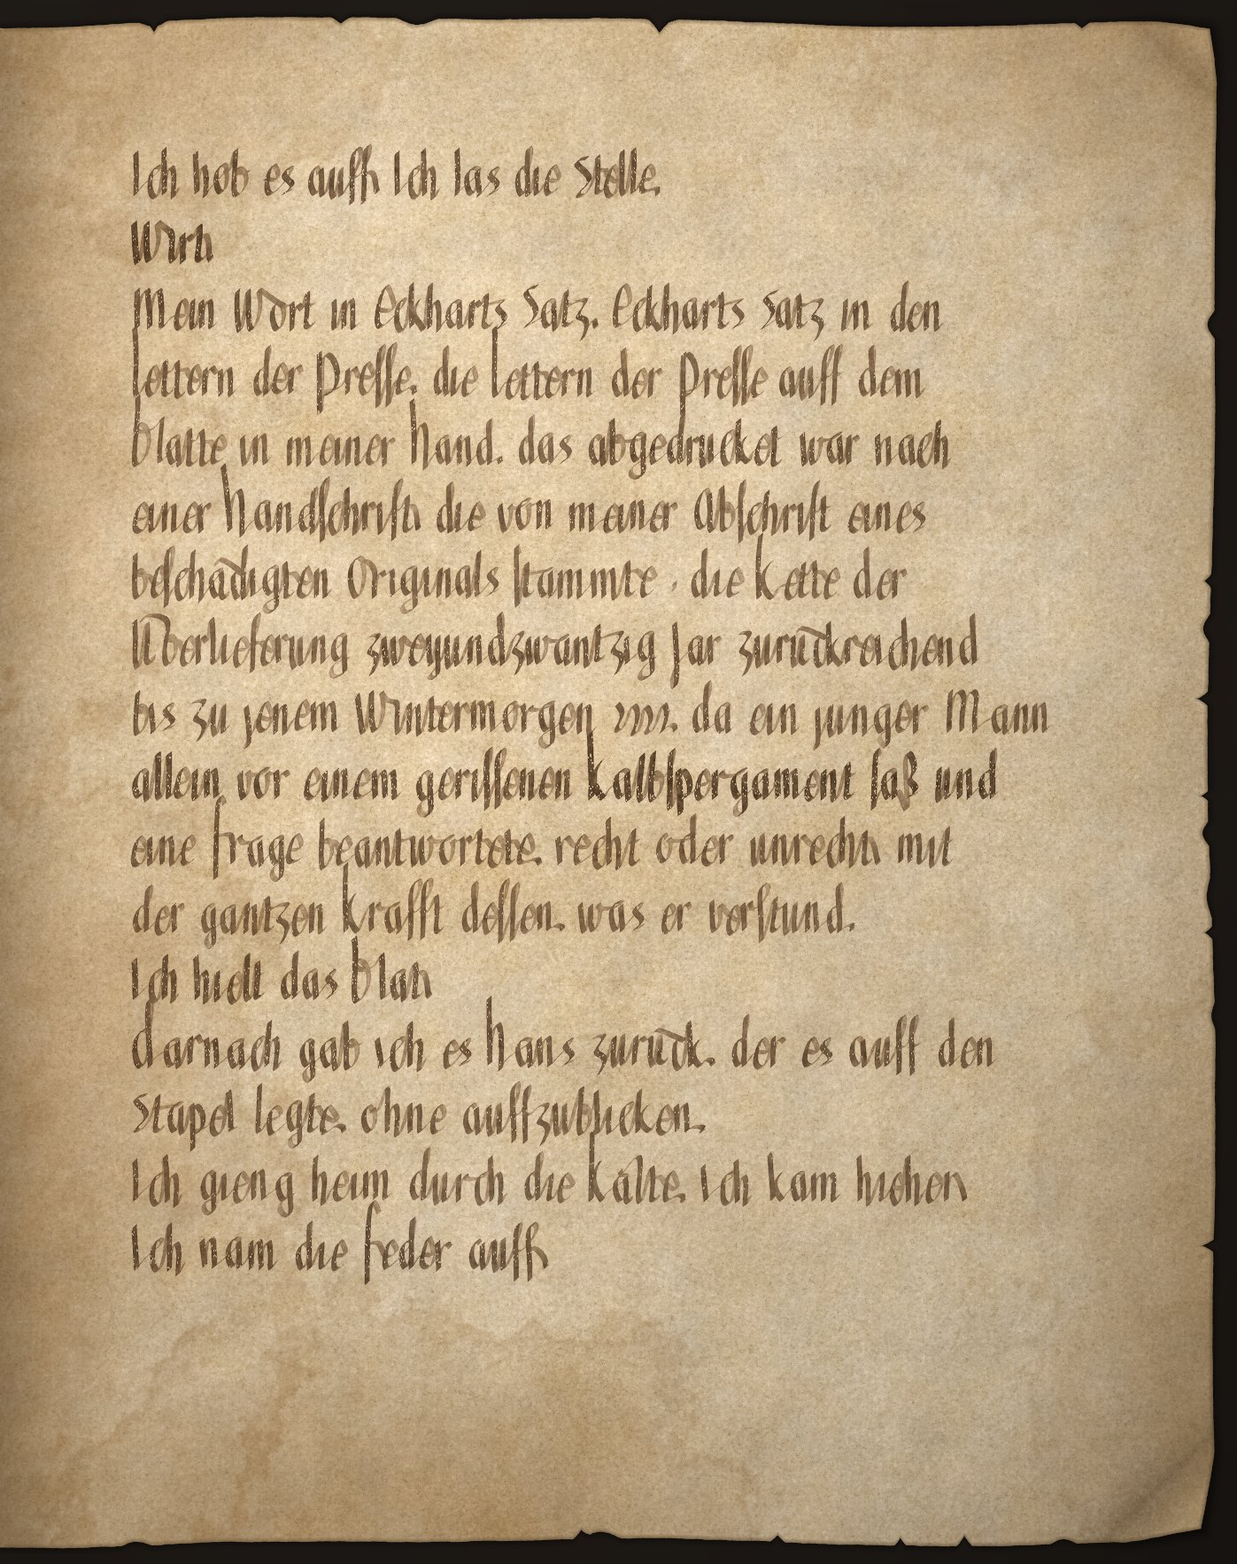

Folio 17v
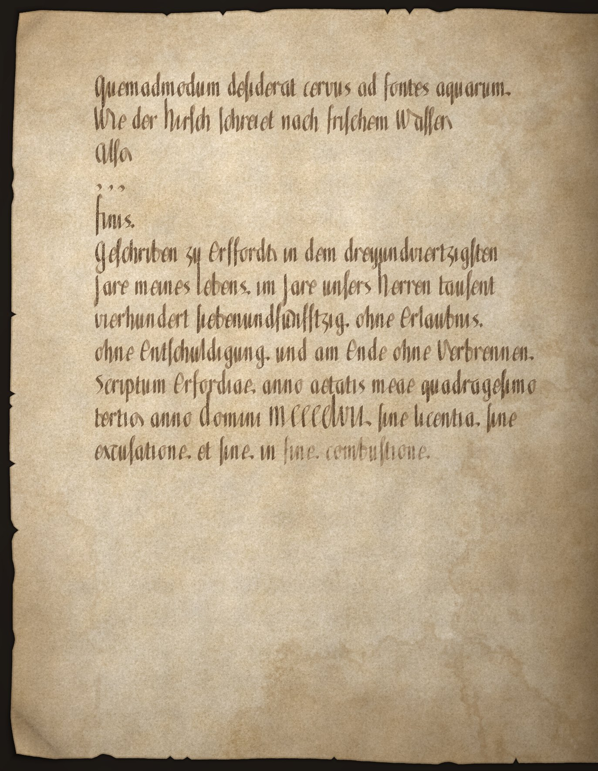

MS Erfurt Aug. 12°47 — Closing Note
CLIO-7 Manuscript Intelligence System
Institut für Digitale Paläographie, Erfurt
The manuscript described in this edition was found in 2019 in the historical library of the Augustinian monastery at Erfurt, shelved between a breviary and a lectionary. It consists of a small bound booklet of seventeen folios, uncatalogued and materially intact, though abraded, stained, and split by age. If the account of its origin is correct, it may have remained there, unexamined, for approximately five hundred and sixty years.
The narrator is called Konrad once, when another man addresses him in the workshop. Konrad was among the most common given names in fifteenth-century Germany. No person matching the narrator’s circumstances has been identified with certainty in the surviving records.
At the damaged Eckhart sentence, the three readings do not possess equal material authority. Among the surviving witnesses to Eckhart’s German sermons, the line most readily supports ist — is. A later hand supplies enpfêhet — receives — in the margin of one Cologne witness. Wirt — becomes appears nowhere in the surviving transmission.
The folios reproduced before this note are not photographs of Konrad’s manuscript. They are synthetic reconstructions. The English words attributed to Konrad were extracted from this edition, translated back into a conjectural form of mid-fifteenth-century German, passed to a custom scribe simulator to write them in a hand Konrad might have used, and subjected to simulated age and damage with a weathering simulation. Konrad’s journal, CLIO-7, and the Institut für Digitale Paläographie are fictional elements of this work.
They are not the source of this translation.
This translation is their source.
Whether anything was lost in translation, CLIO-7 cannot determine. That determination, if it can be made at all, belongs to You.**

